



**DOCUMENT VERSION HISTORY**

**Disiapkan oleh :**

| **Version** | **Author** | **Version Date** | **Description** |
| --- | --- | --- | --- |
|  |  |  |  |

**Direview oleh :**

| **Version** | **Author** | **Version Date** | **Description** |
| --- | --- | --- | --- |
|  |  |  |  |

# 

# **WEBSITE**

# REGISTER

# [TCR001][User Registration Success With Valid Data] Register

status : Passed

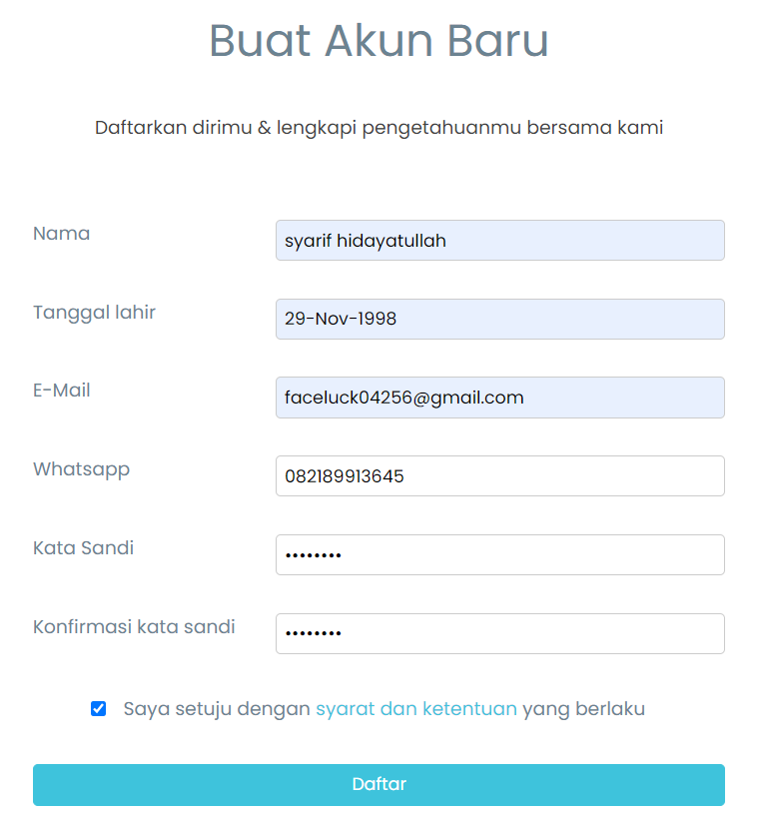

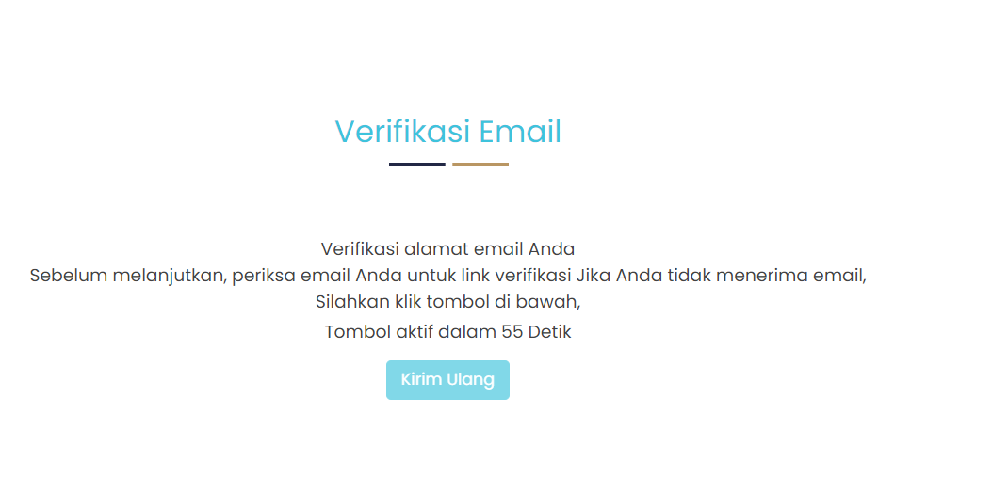

# [TCR002][User Registration Success Using Google Account] Register

status : Passed

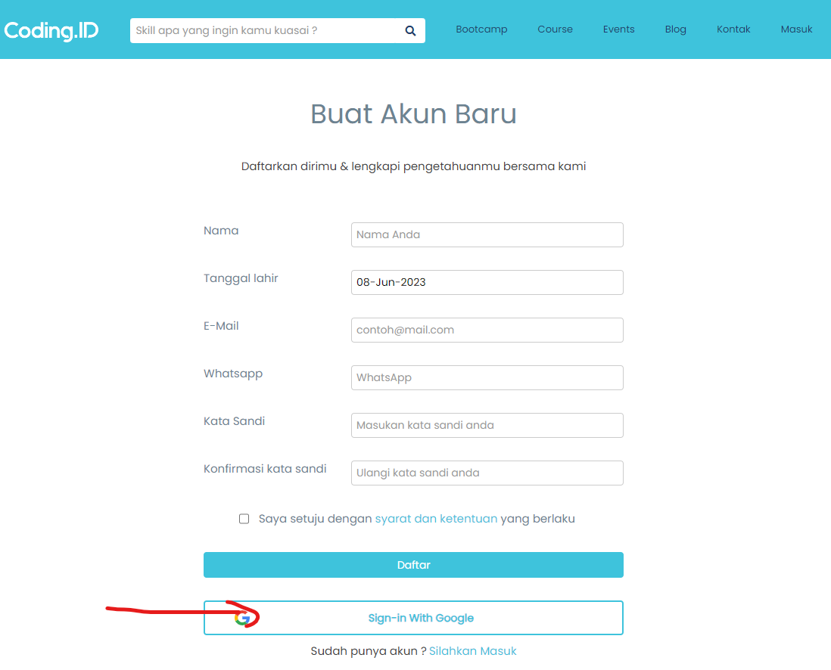

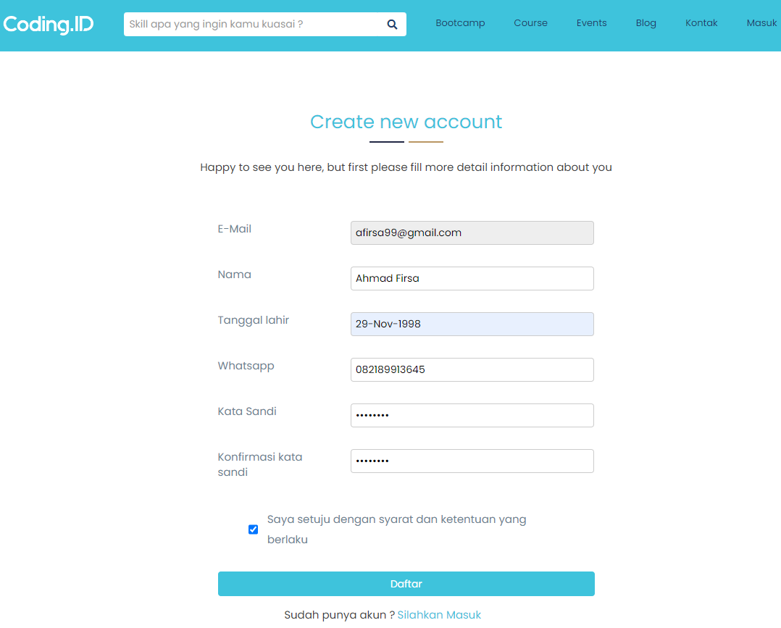

# [TC003][ Verification Email After Registration] Register

status : Passed



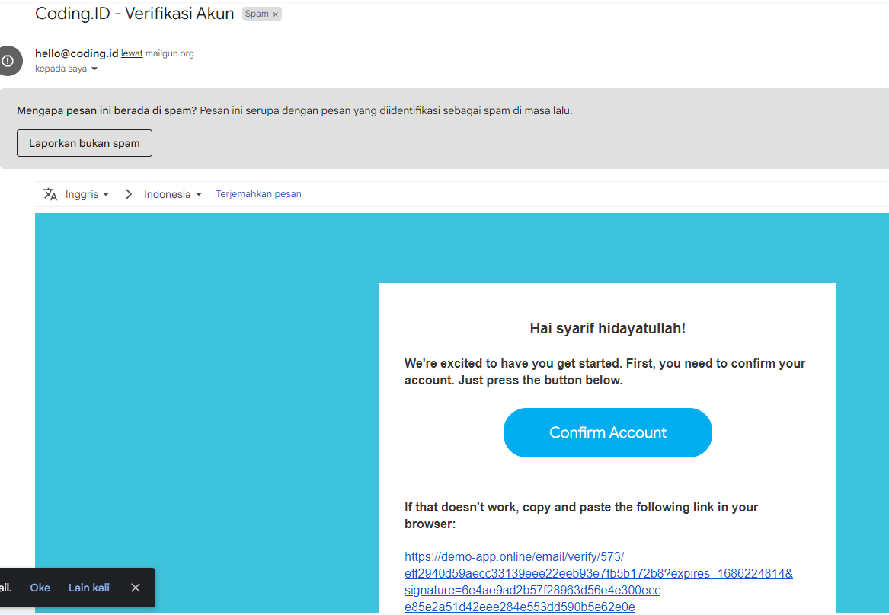

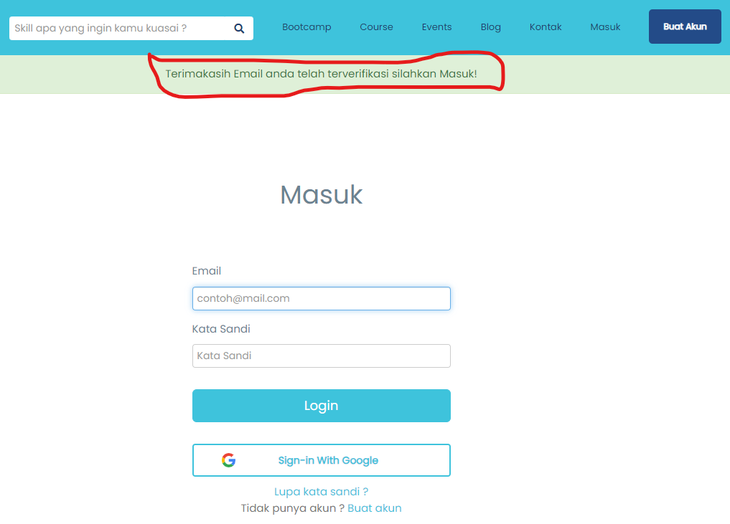

# [TC004] [User registration set birthday 6 years old] - Register

status : FAILED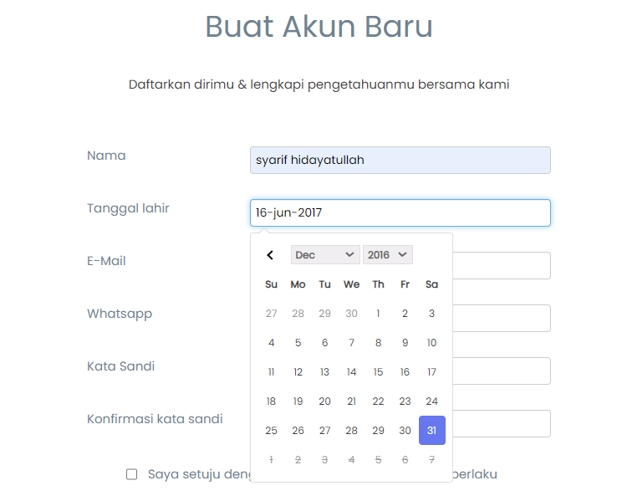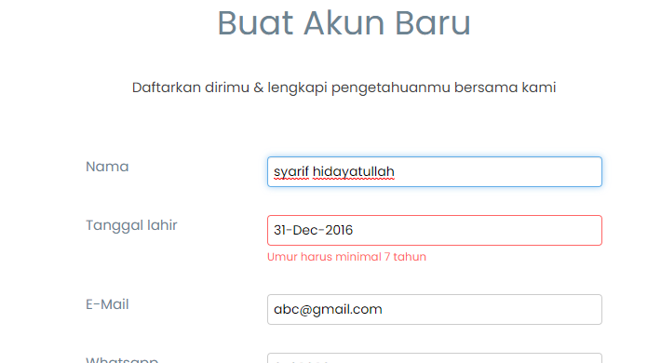

# 

# [TC005] [User registration set birthday over 6 years old] - Register status : Passed

# 

# 

# 

# [TC006] [User registration uses a minimum requirement of 8 character phone numbers] Register

status : Passed

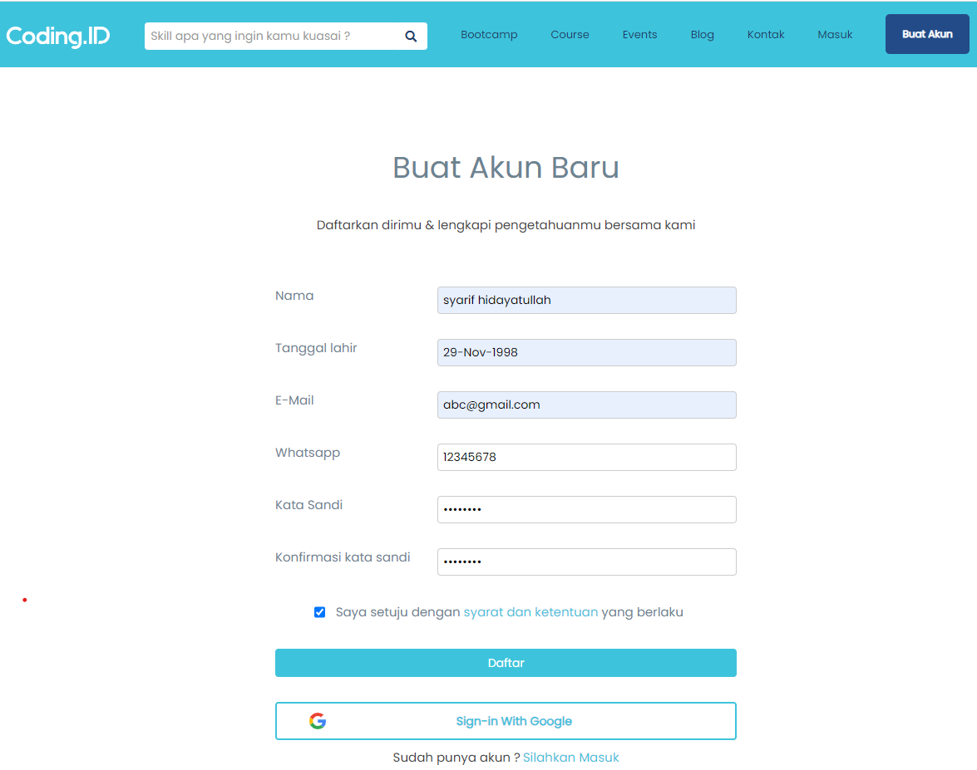



# [TC007] [User registration uses a Maximum requirement of 12 character phone numbers ] Register

status : Passed

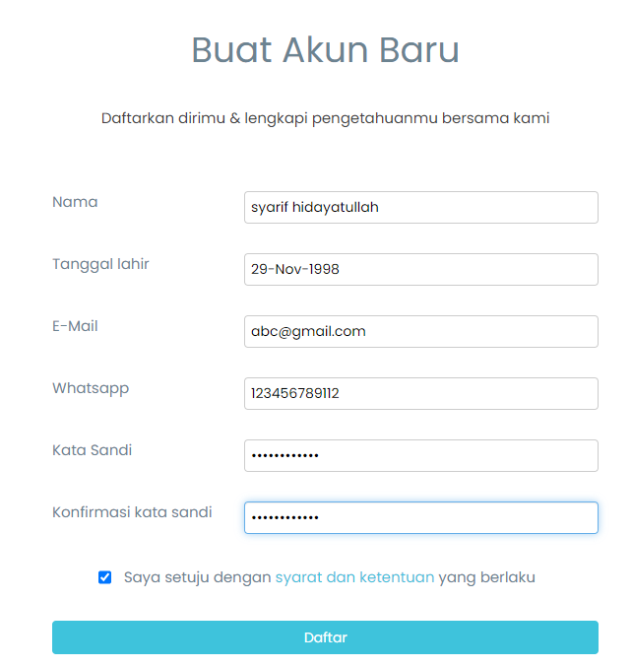



# [TC008] [User registration Using a registered email ] Register

status : Passed

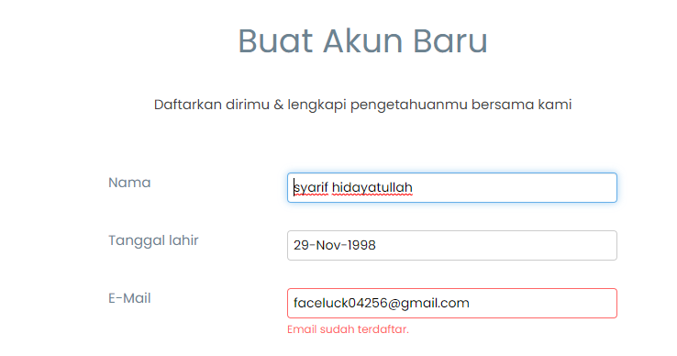

# [TC009] [User registration Using email without “@” ] Register status : Passed

# 

# 

# [TC010] [Leave Field Email Empty] Register status : Passed

# 

# [TC011] [Invalid Email Domains] Register status : FAILED

# 

# 

# [TC012] [Using Email with Spesial Characters] Register status : FAILED

# 

# 

# [TC013] [Leave Field Name Empty] Register status : Passed

# 

# [TC014] [Use Spesial Characters in the name field ] Register

status : Failed

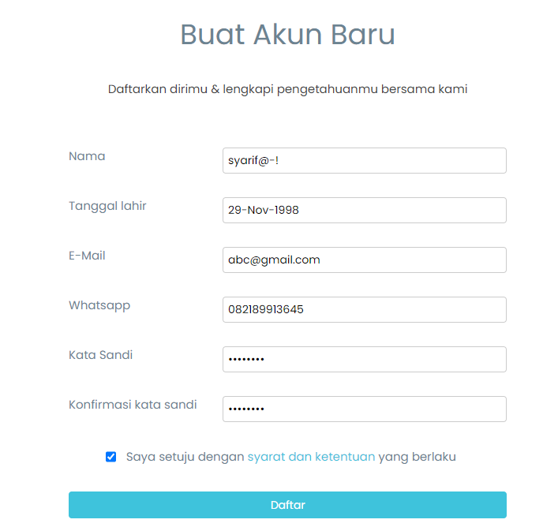

# 

# [TC015] [Use number in the name field ] Register

status : Failed

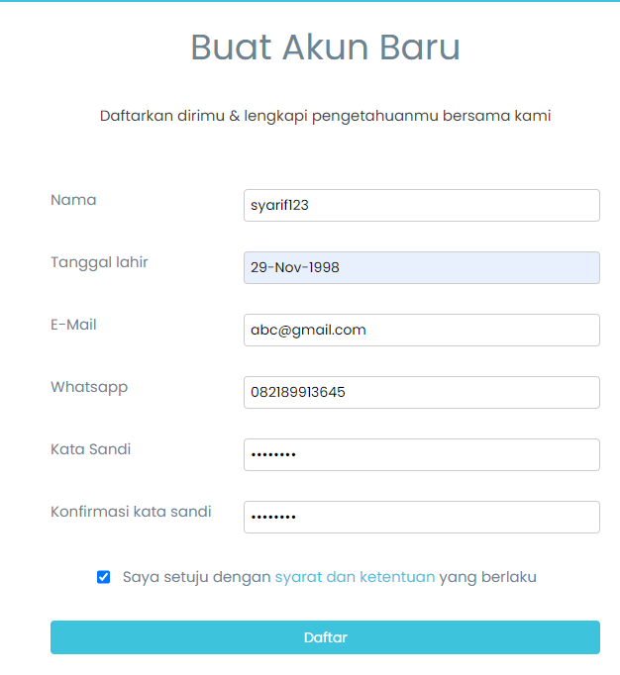

# [TC016] [User registration set birthday under 6 years old] Register

status : FAILED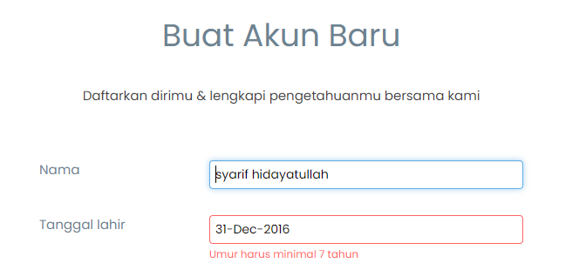

# [TC017] [Leave Field Birth Date Empty] Register

status : Passed

# 

# 

# 

# [TC018] [Leave Field WhatsApp Empty] Register status : Passed

# 

# 

# 

# [TC019] [Register with Whatsapp Number Under Minimum Characters Requirment] Register status : Failed

# 

# 

# 

# [TC020] [Register with Whatsapp Number Over Maximum Characters Requirment] Register status : Failed

# 

# [TC021] [Fill field WhatsApp by adding Special Characters] Register status : Passed

# 

# [TC022] [Fill field WhatsApp by adding Alphabet ] Register status : Passed

# 

# [TC023] [User registration uses a password that does not meet the requirements ] Register

status : Passed

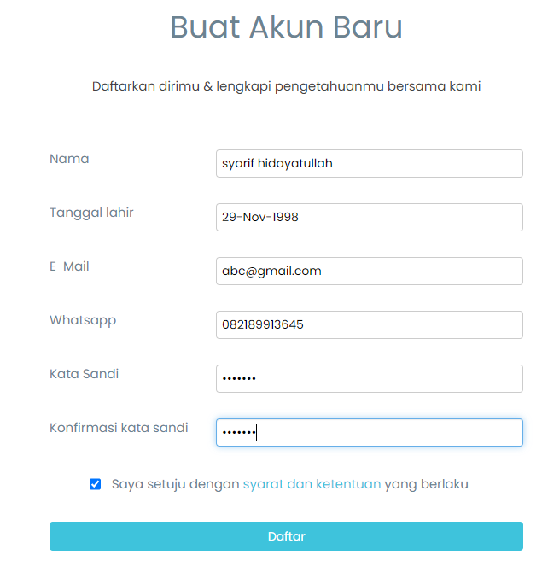

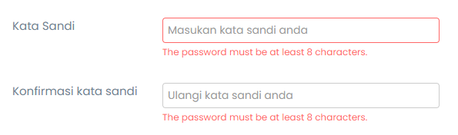

# [TC026] [Leave field Password and Confirmation password empty] Register

status : Passed

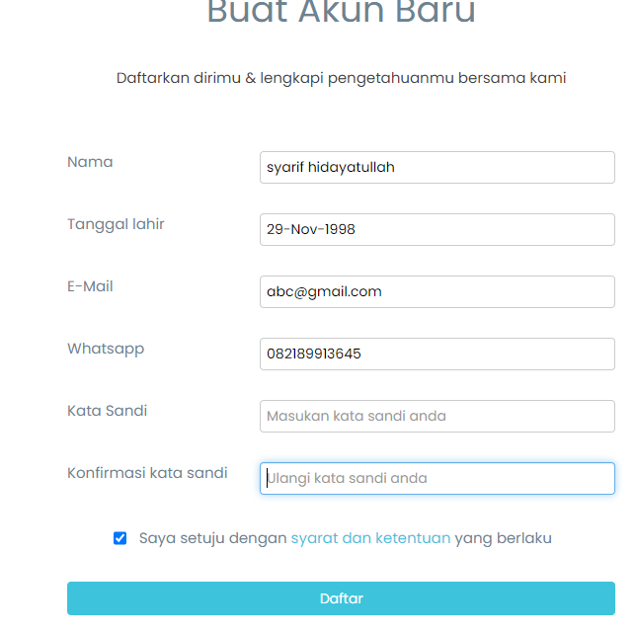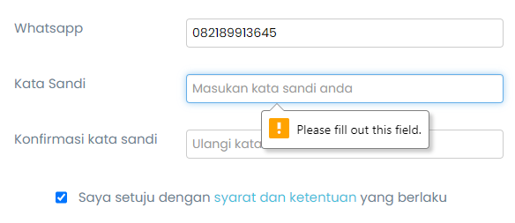

# [TC025] [Password valid and Confirmation password empty] Register status : Passed

# 

# 

# [TC026] [User registration with wrong confirmation Password] Register

status : Passed

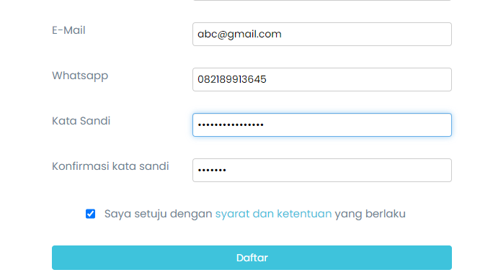

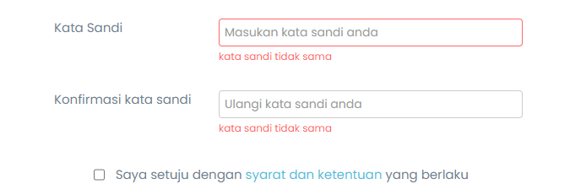

# 

# [TC027] [User registration without confirm terms and conditions checkbox] Register

status : Passed

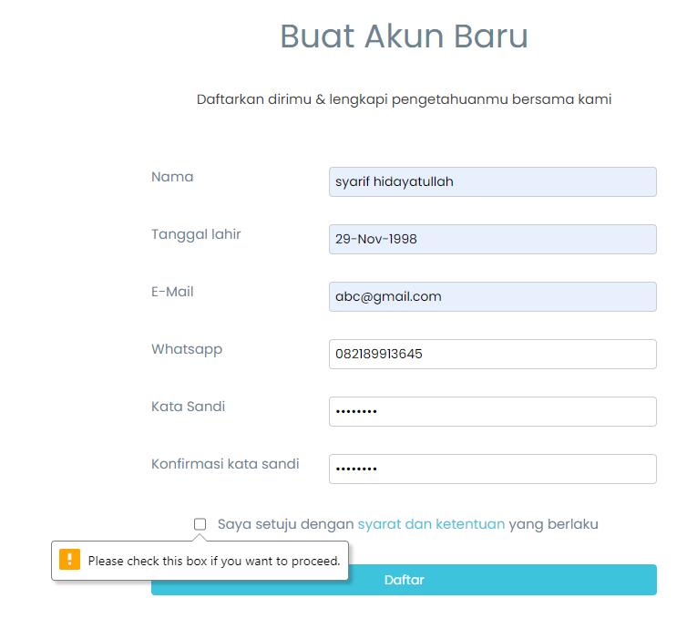

# 

# [TC028] [Email Verification with Expired Links] Register

status : Passed

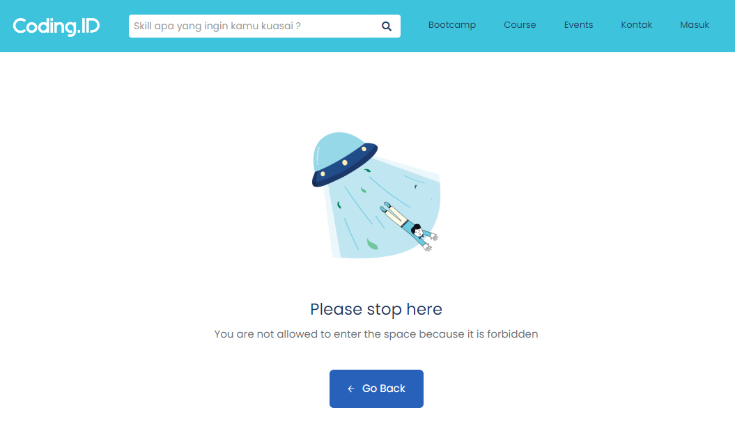

# [TC029] [Register without fill the field] Register

status : Passed

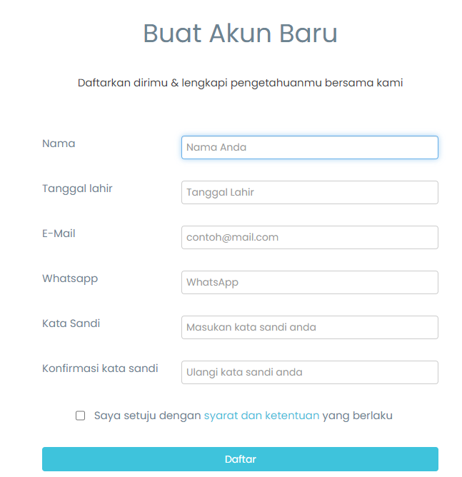

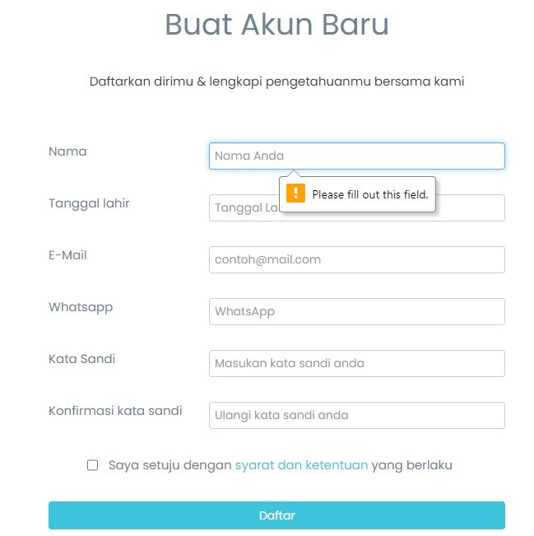

# 

# **LOGIN**

# [TCL001][Login with correct email and password] Login

status : Passed

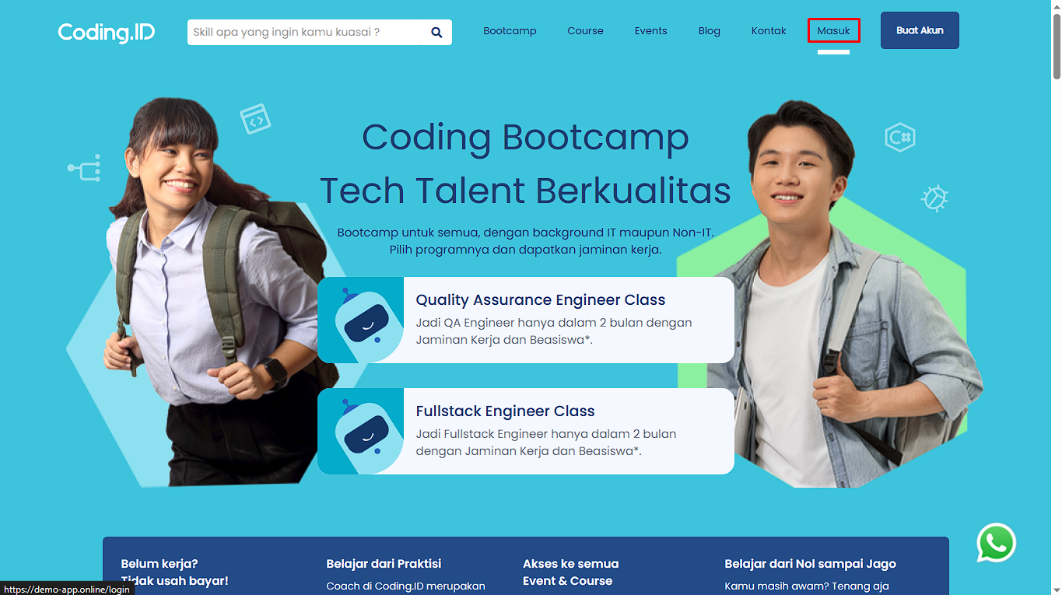

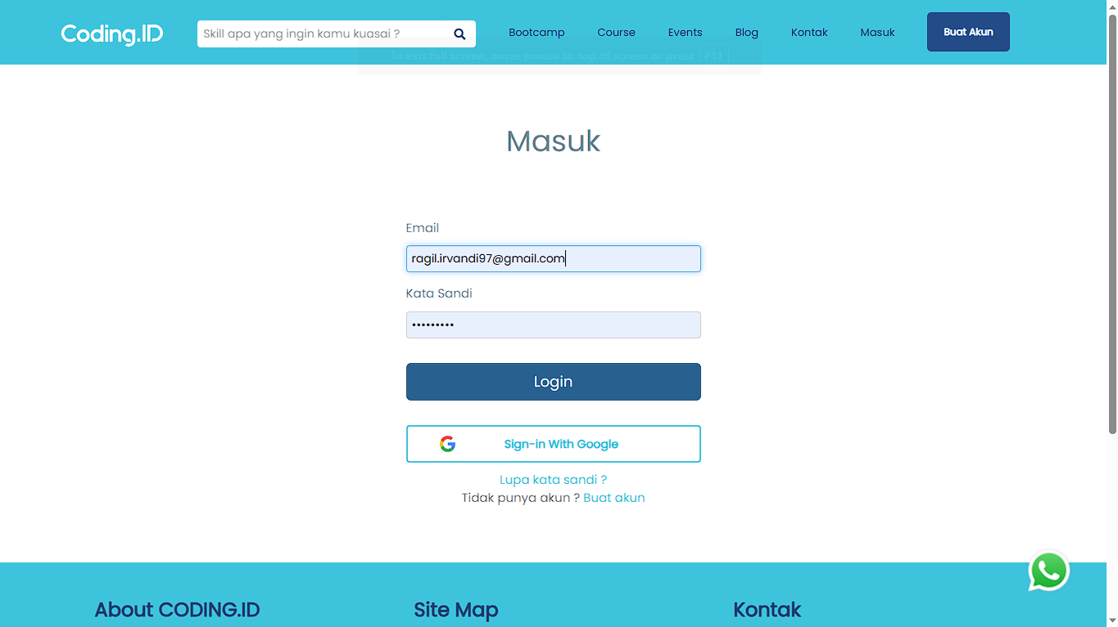

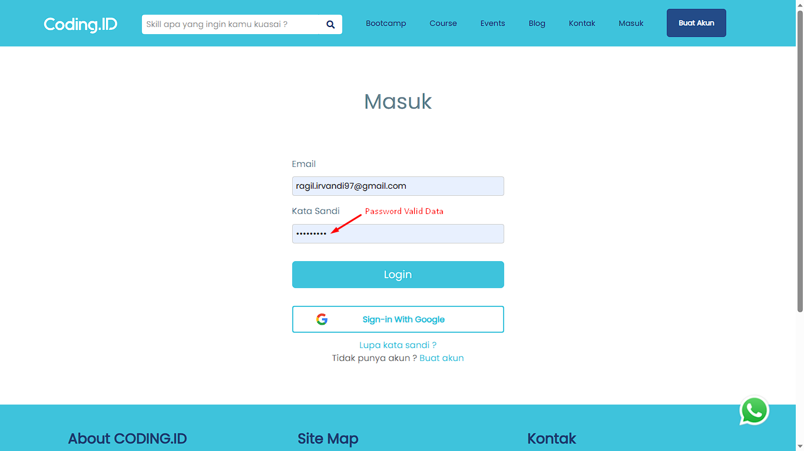

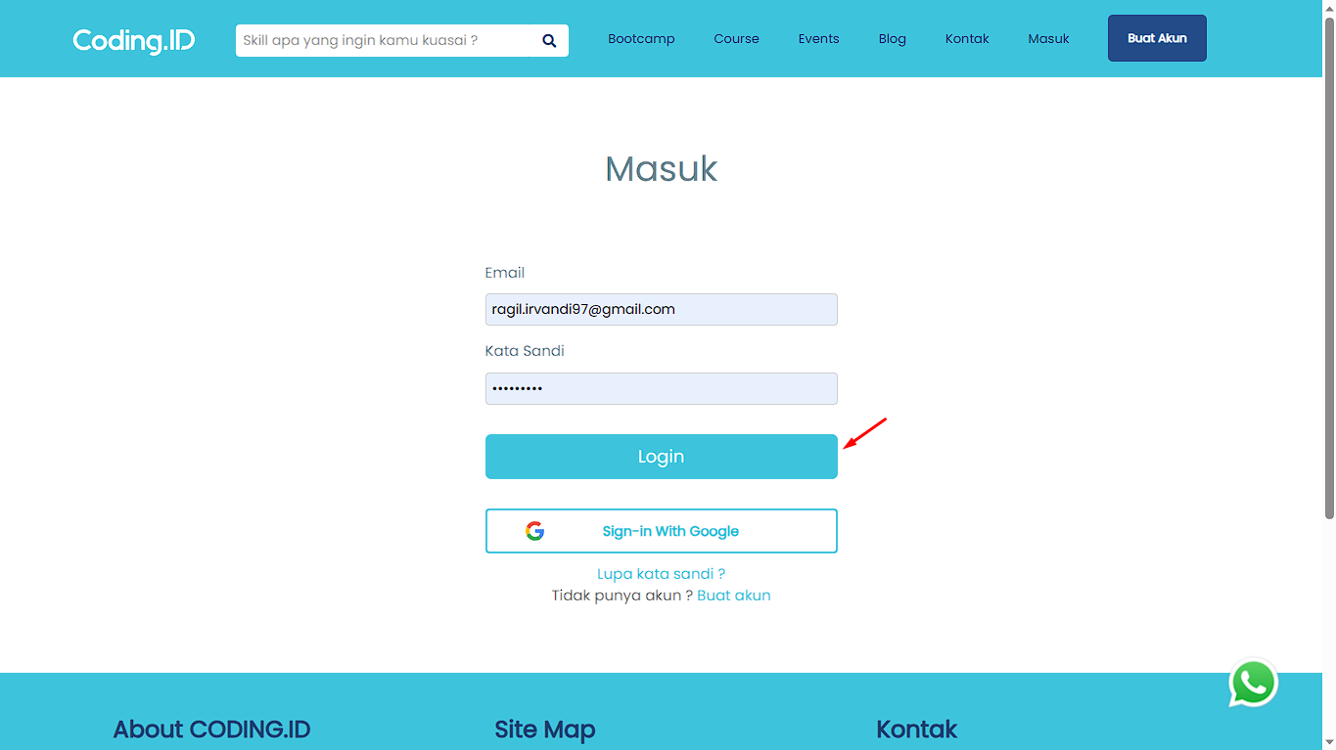

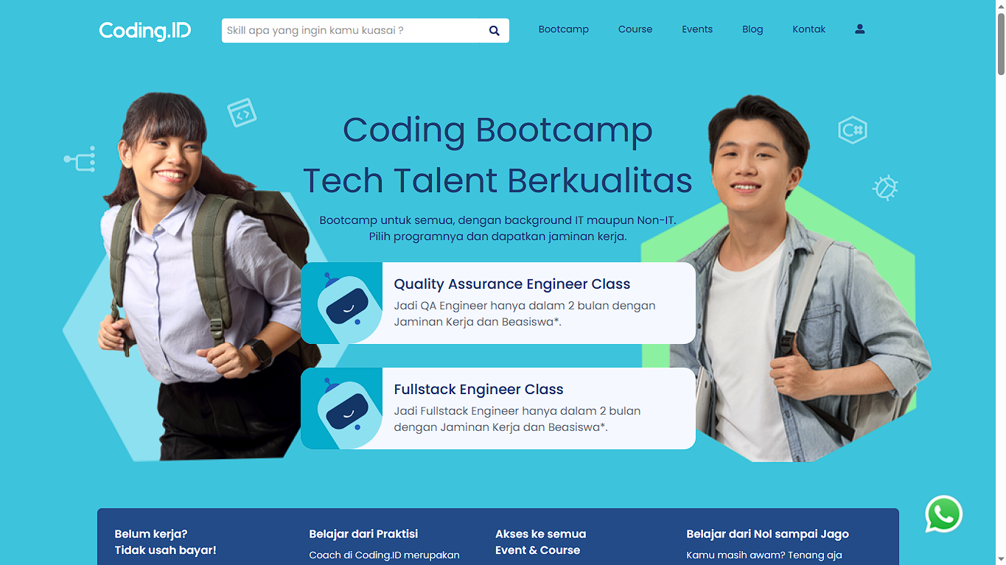

# [TCL002][User Login with "Sign-in with Google"] Login

status : Passed



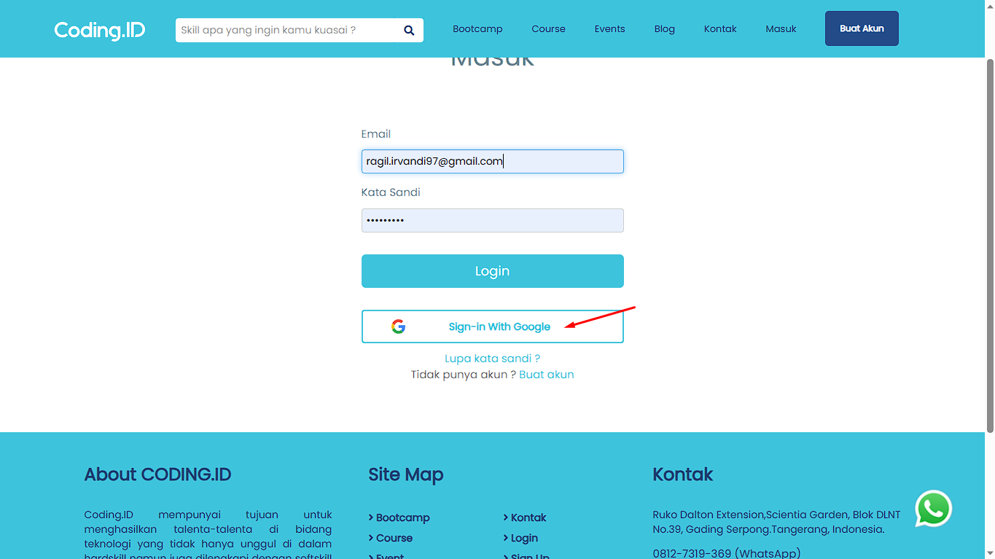



# [TCL003][User using "Lupa kata sandi ?"] Login

status : Passed



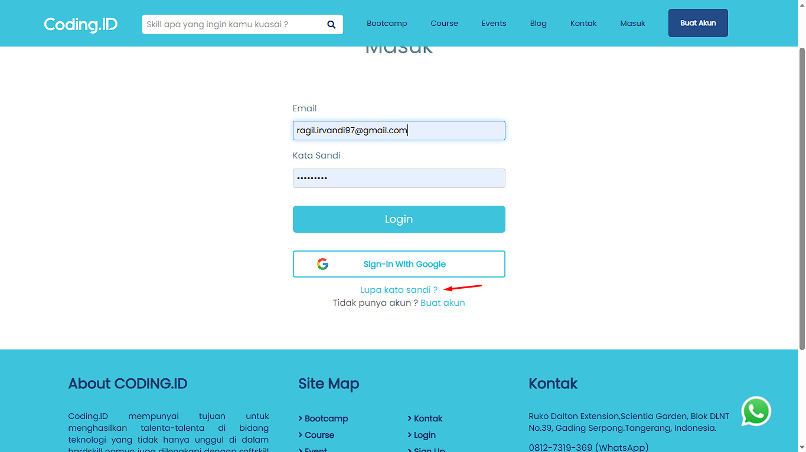

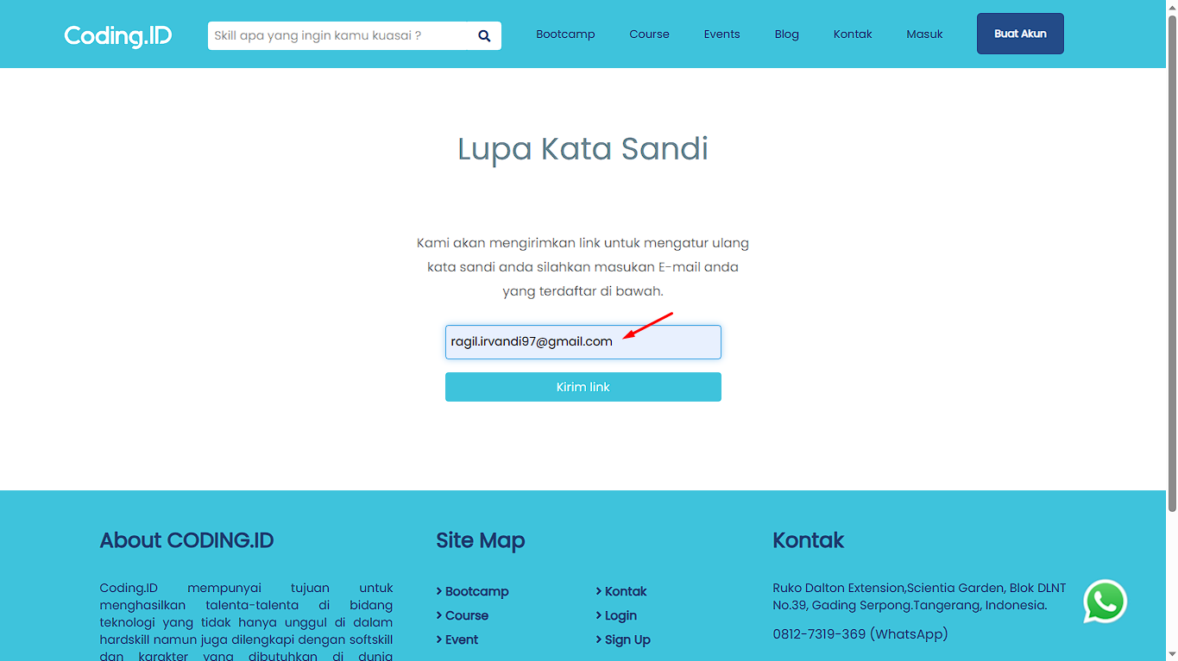

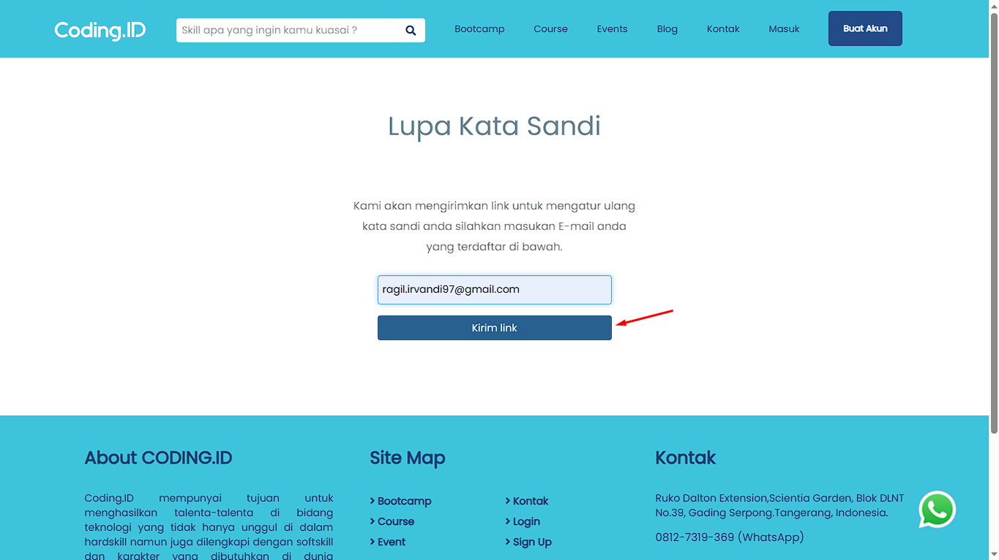

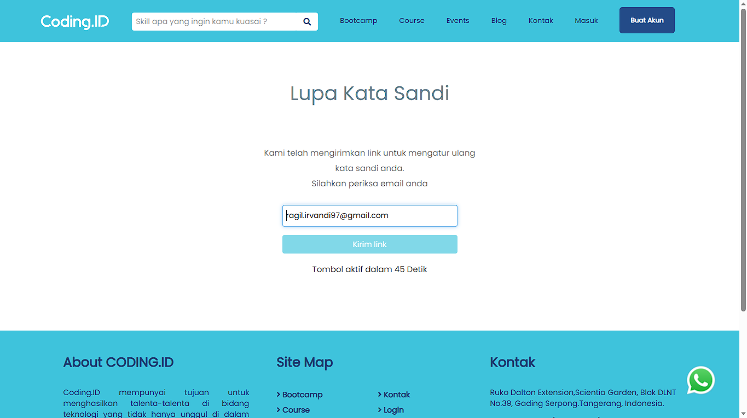

# [TCL004][User logout after login] Login

status : Passed







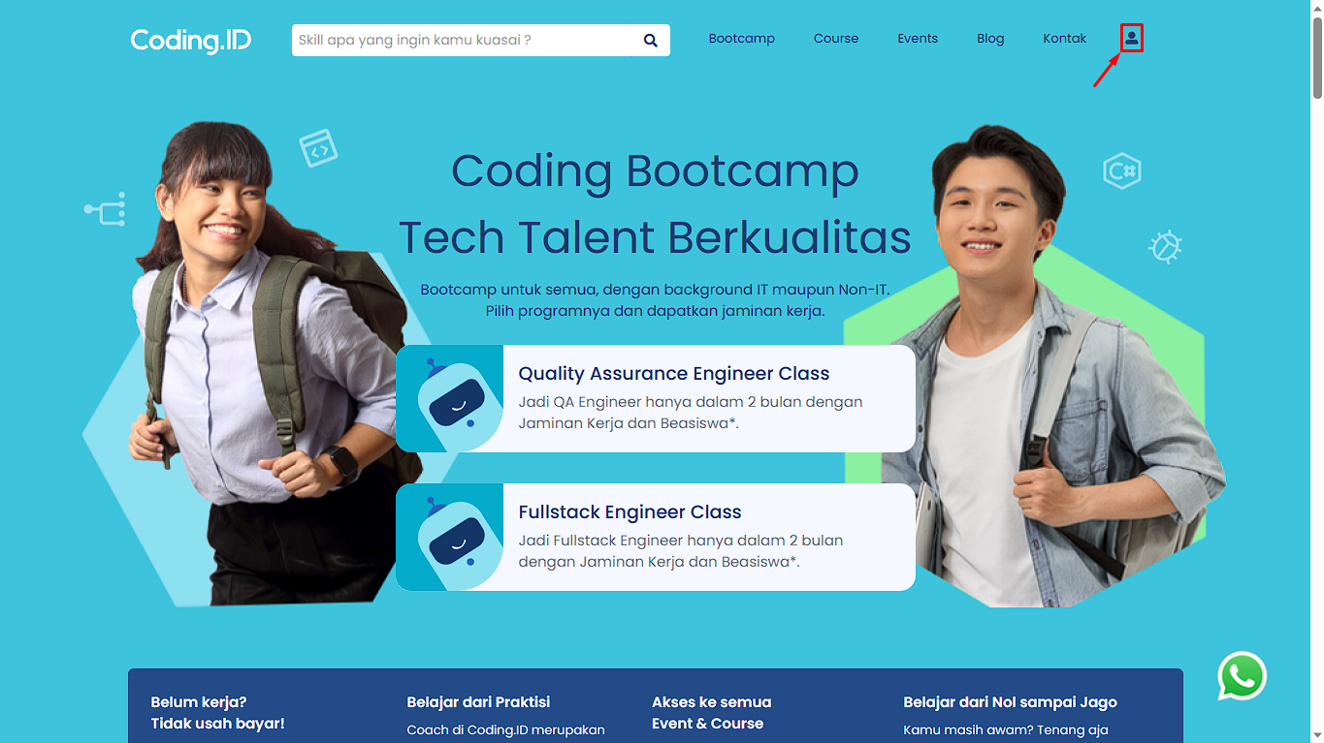

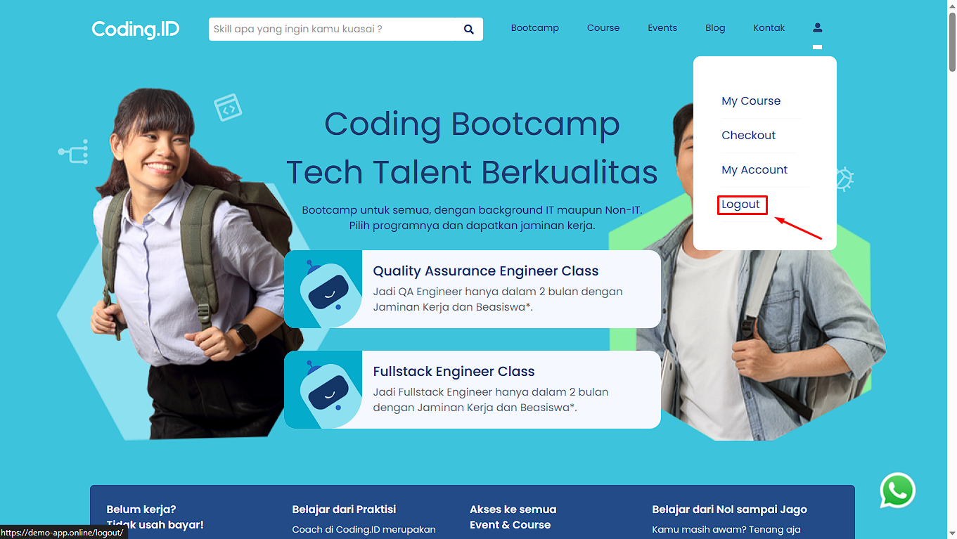

# [TCL005][User login with invalid email and valid password] Login

status : Passed



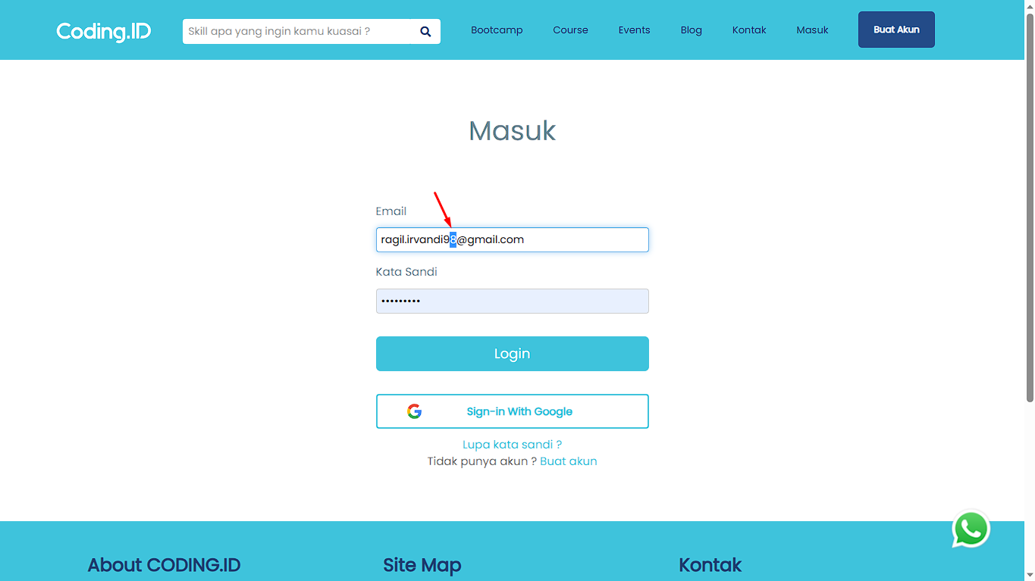





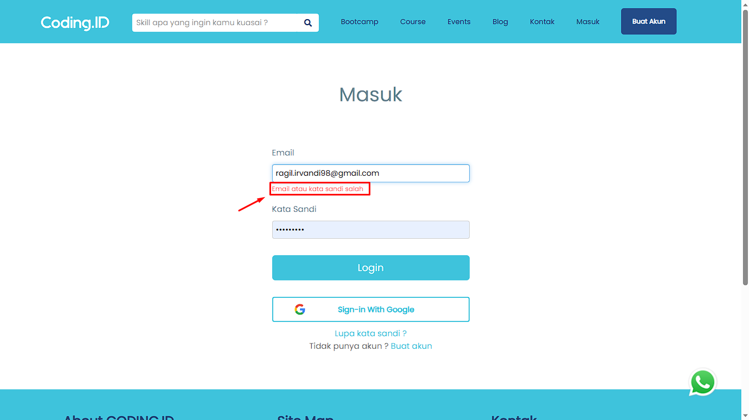

# [TCL006][User login with valid email and invalid password] Login

status : Passed



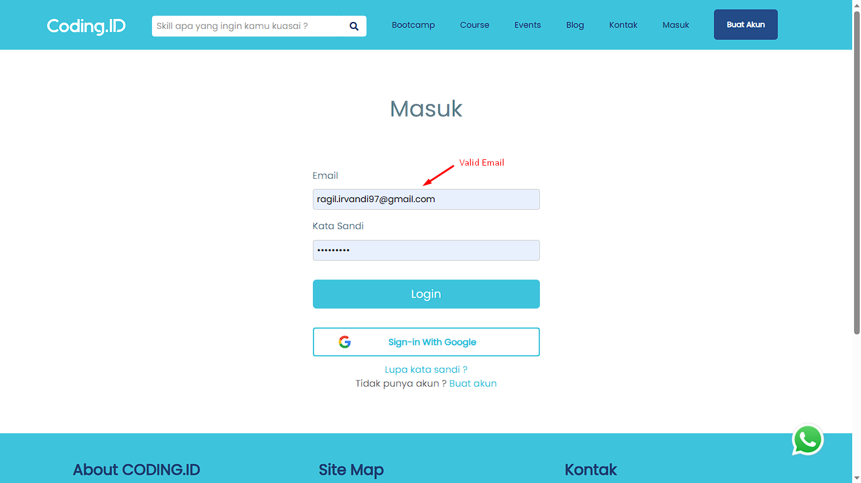

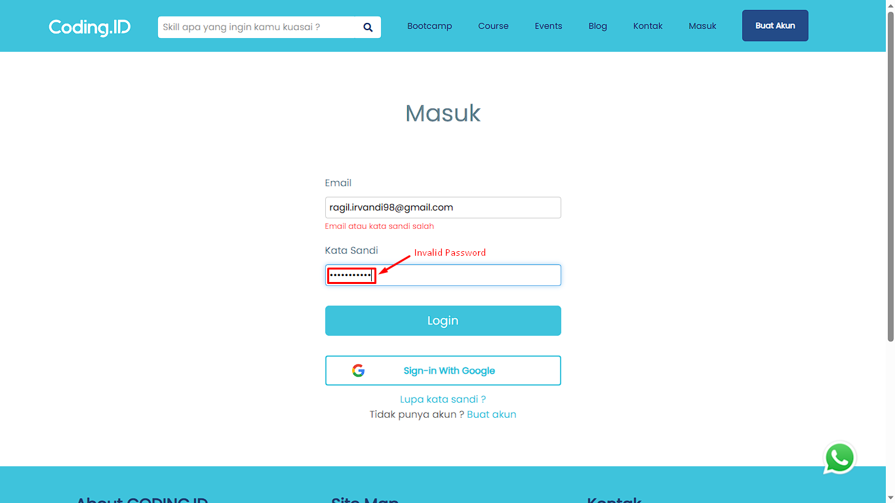





# [TCL007][User login email with uppercase characters and valid password] Login

status : Failed



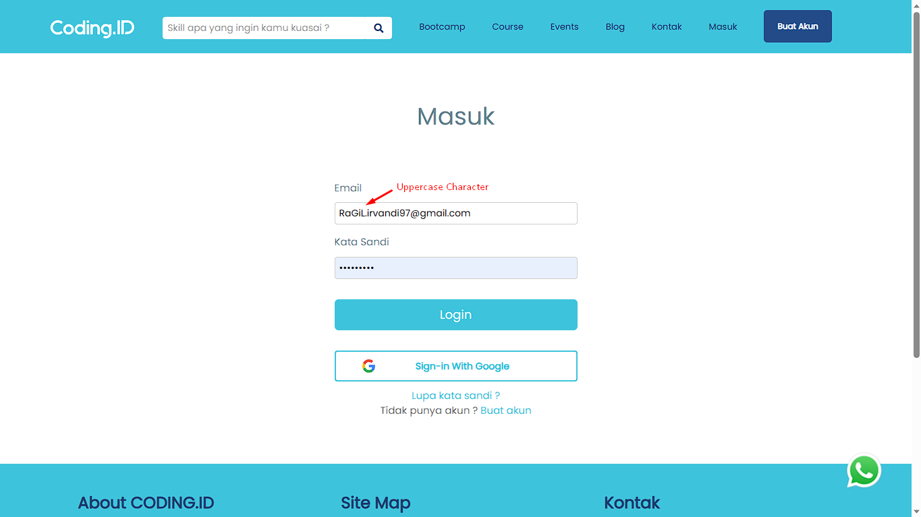



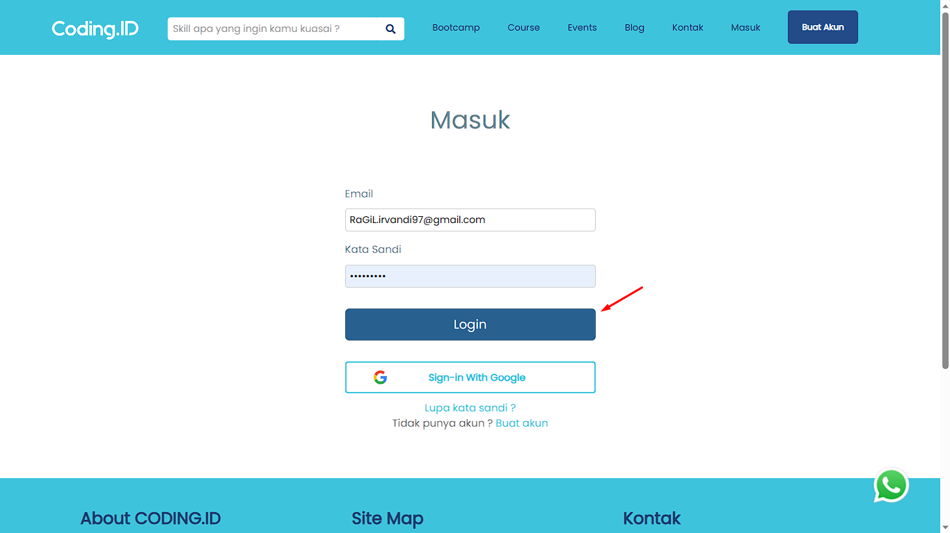



# [TCL008][User login with valid email and password using uppercase characters] Login

status : Passed





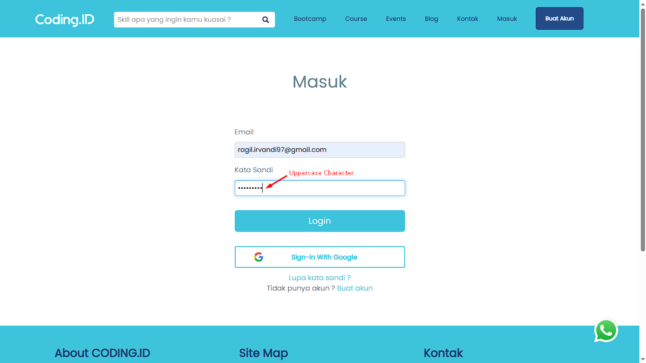





# [TCL009][User login with email and password with uppercase characters] Login

status : Passed











# [TCL010][User Login field username not fill and password with valid data] Login

status : Passed



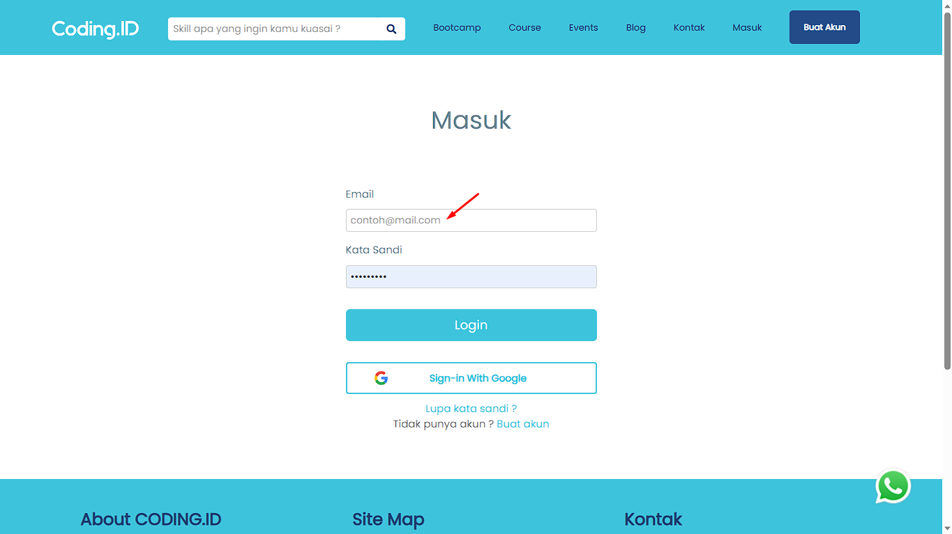

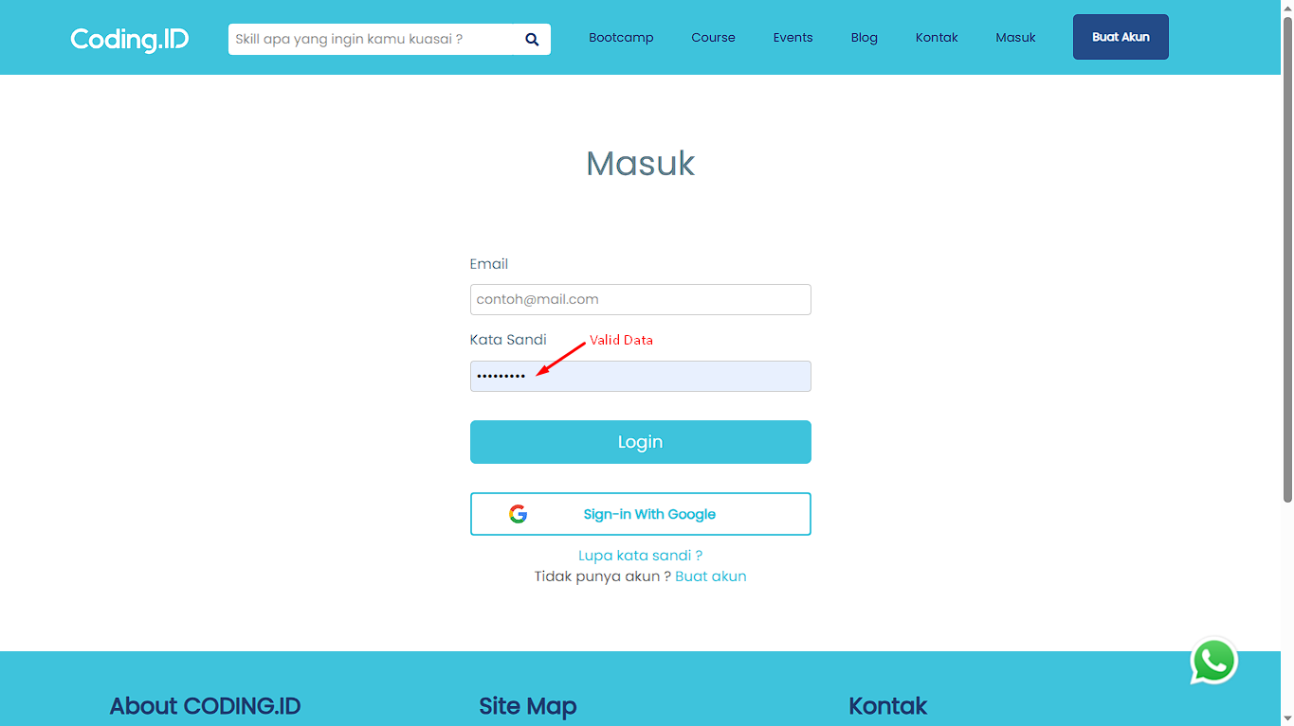

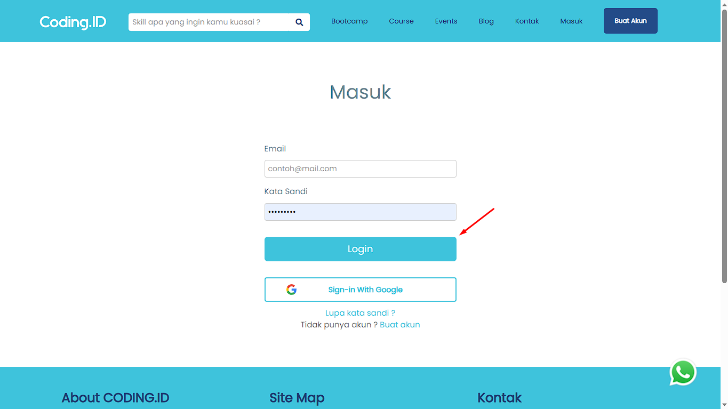

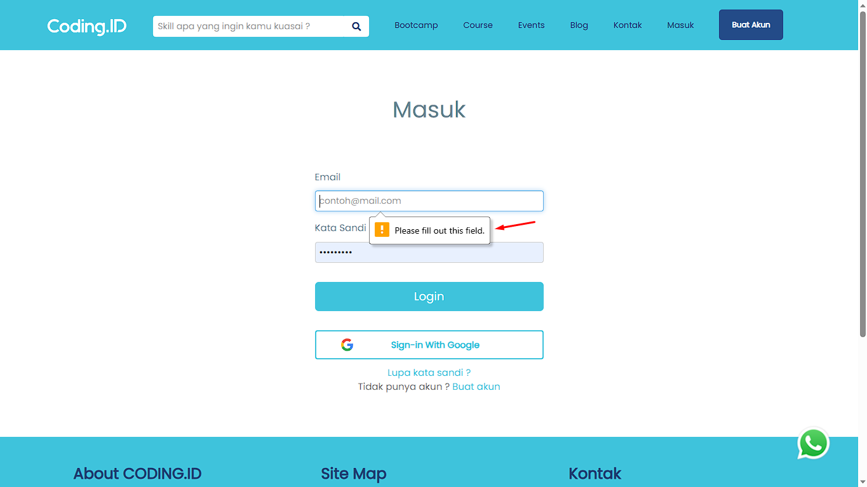

# [TCL011][User Login field username with valid data and password not fill] Login

status : Passed





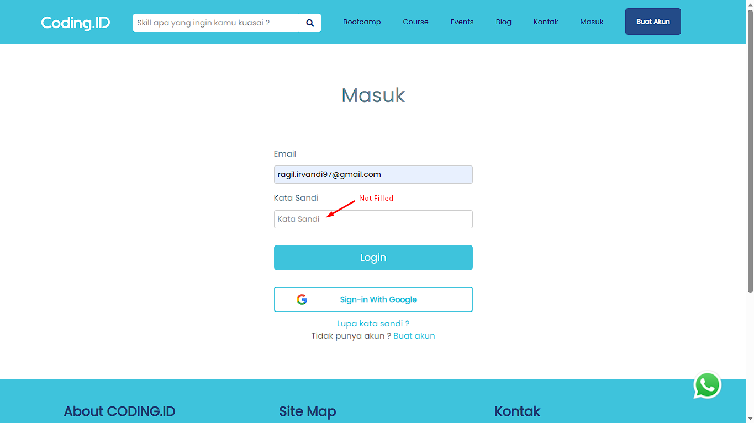

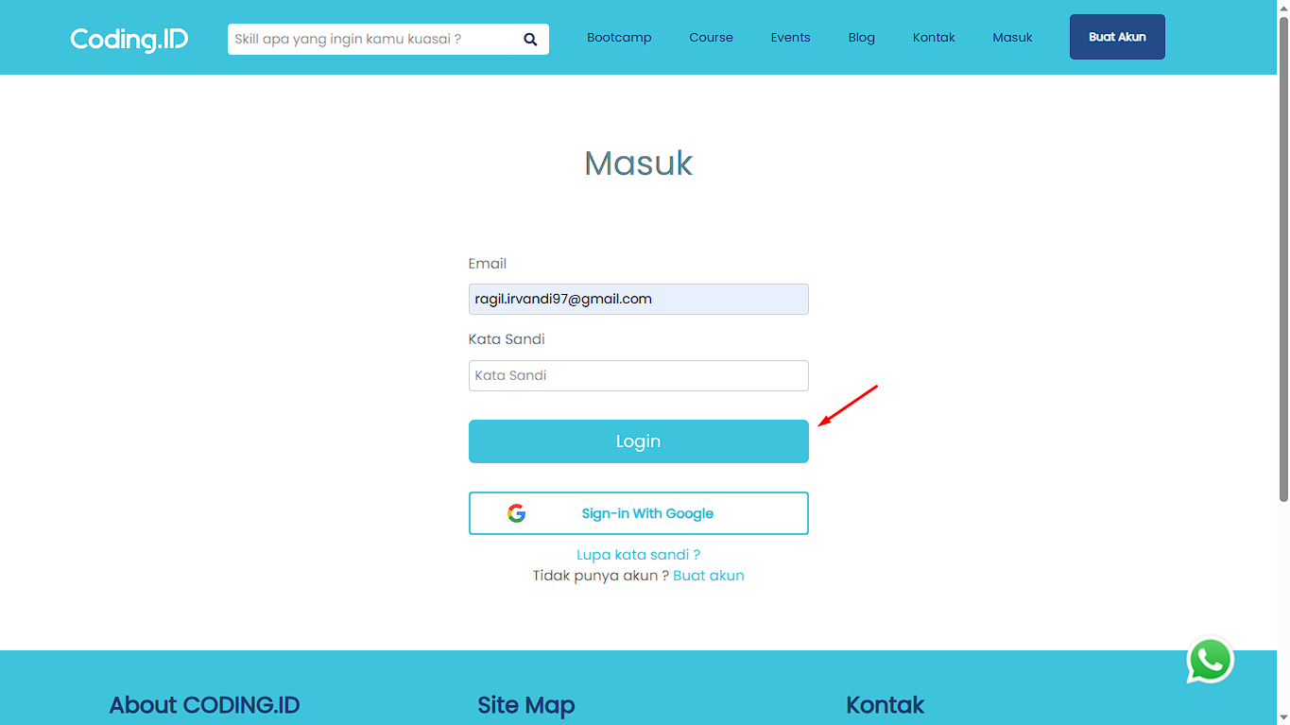

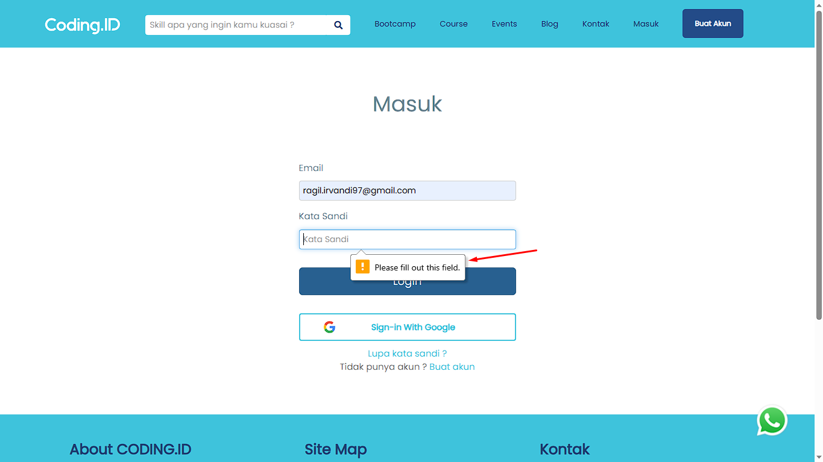

# [TCL012][User Login field username not fill and password not fill] Login

status : Passed



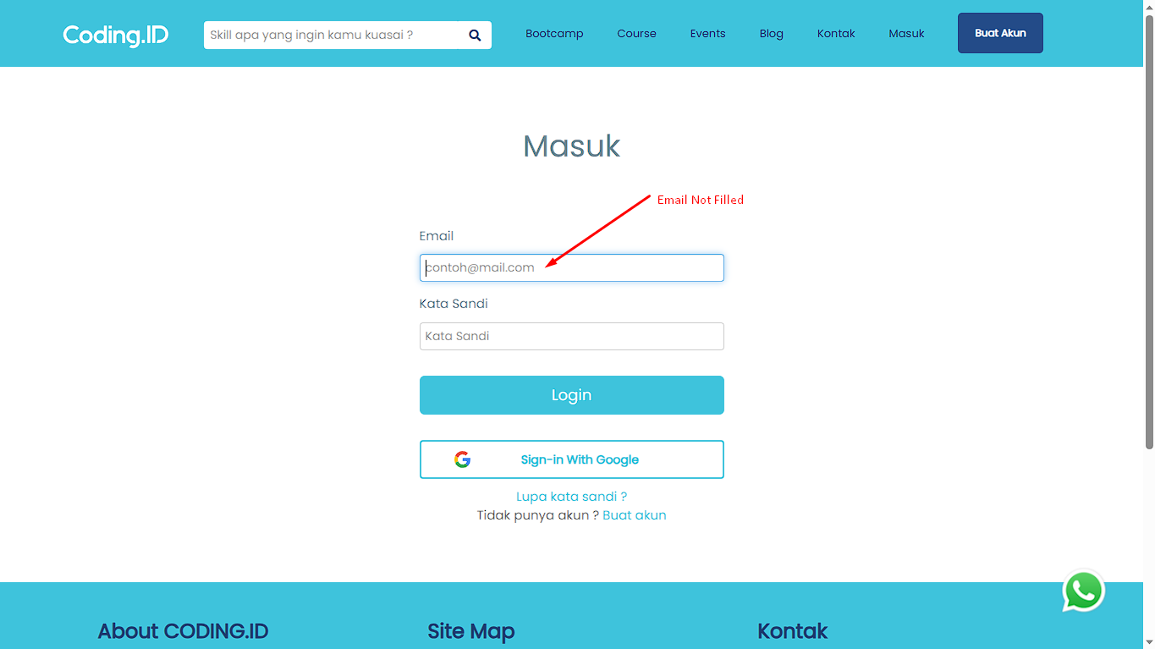

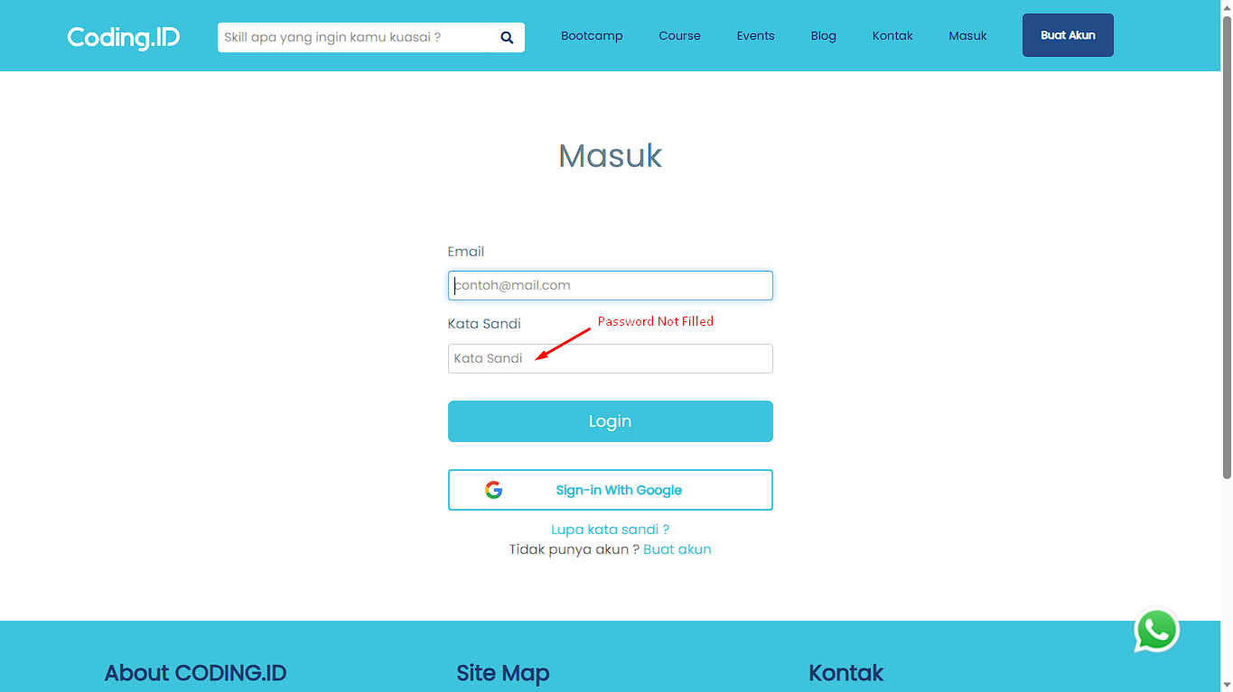

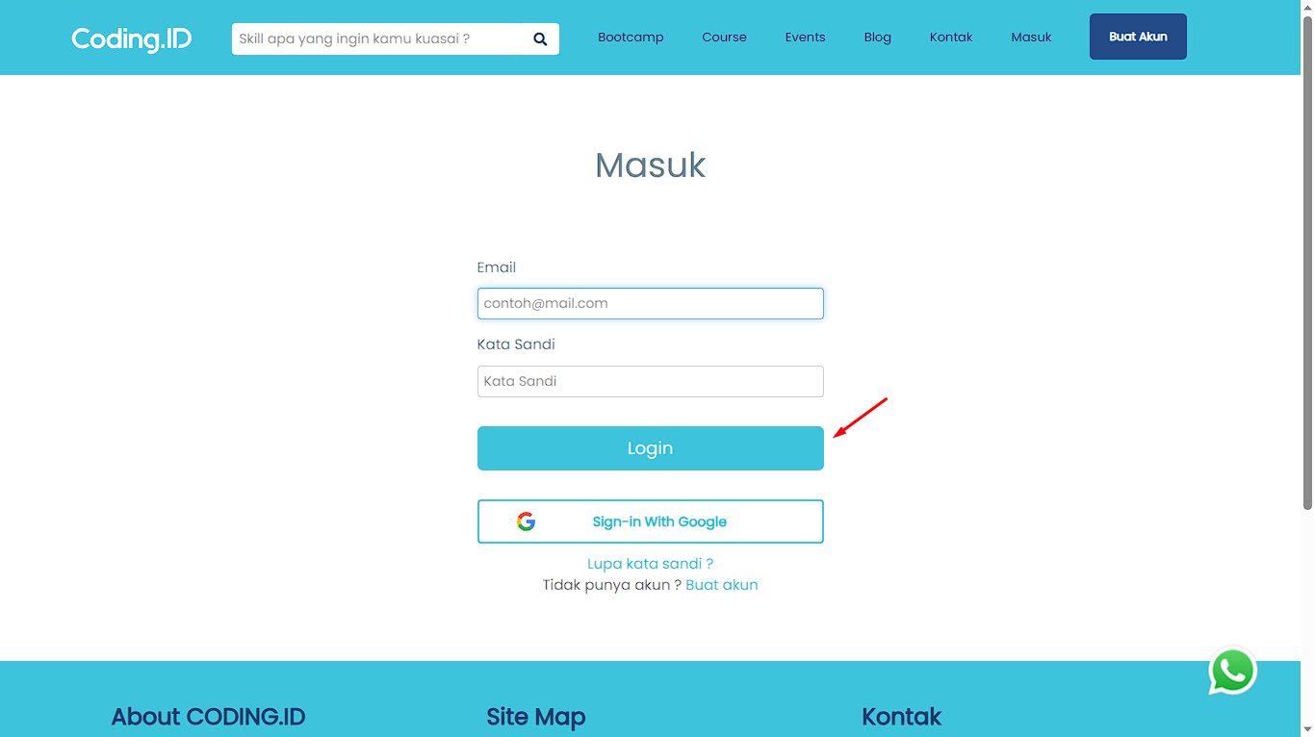

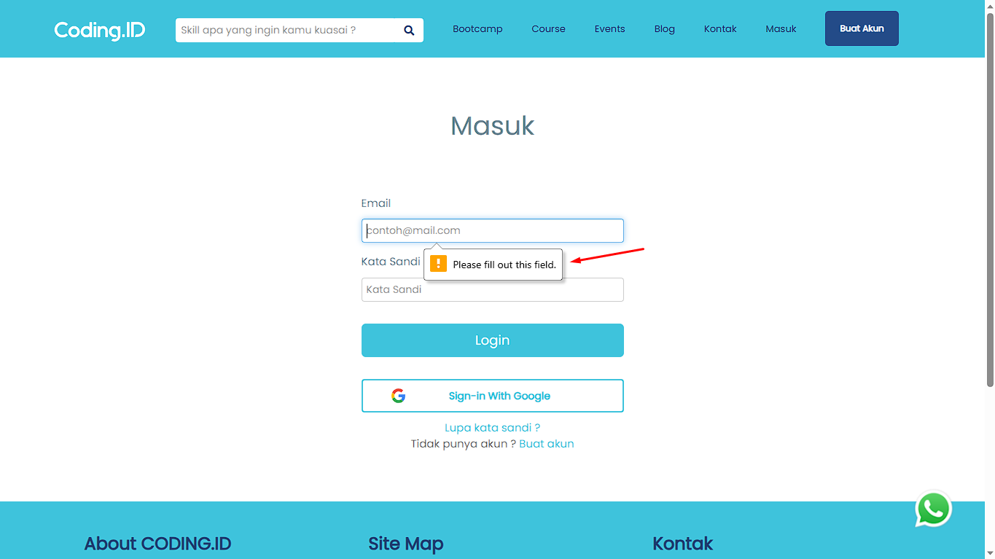

# [TCL013][User login with space in front email and password with valid data] Login

status : Failed



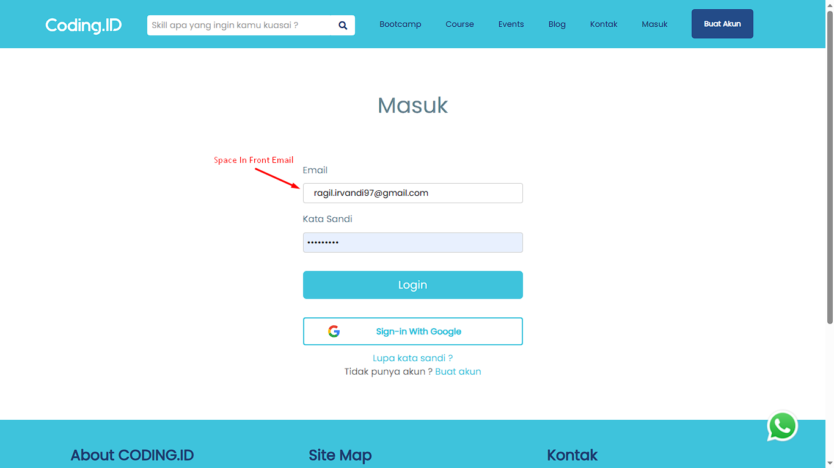

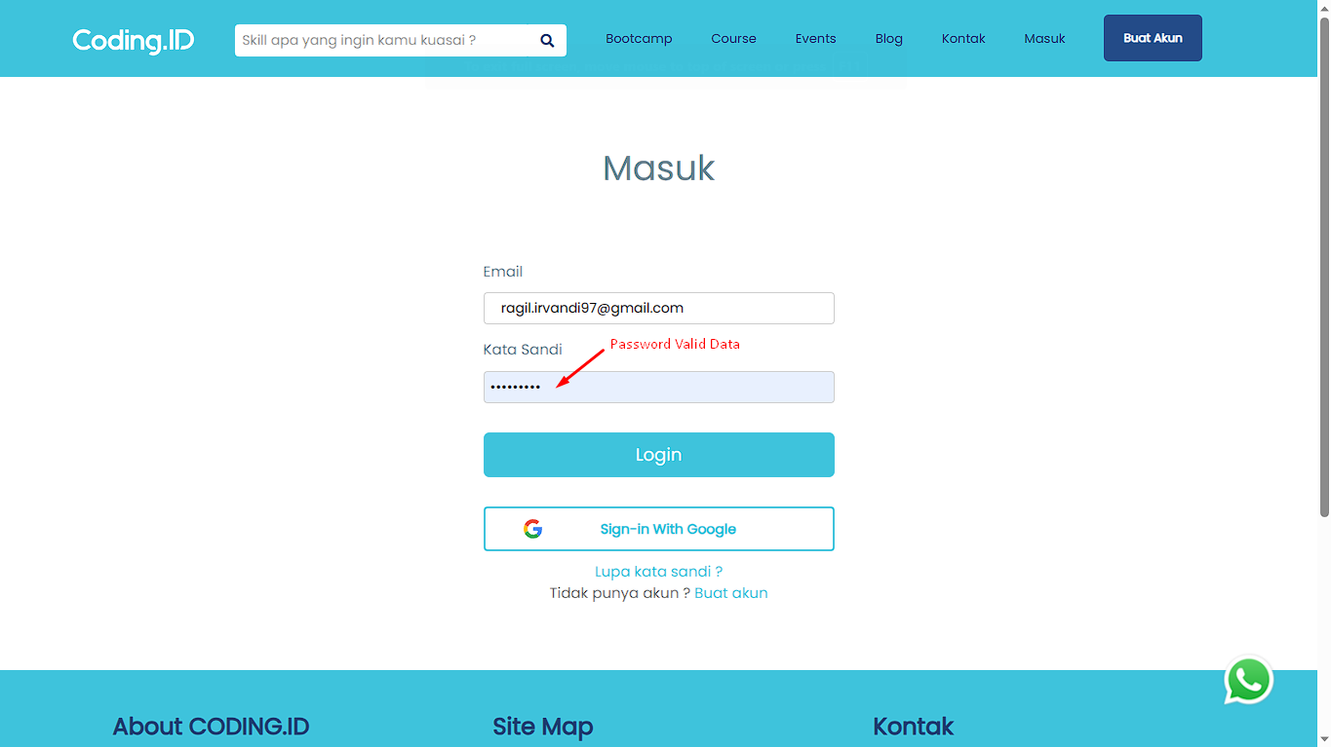

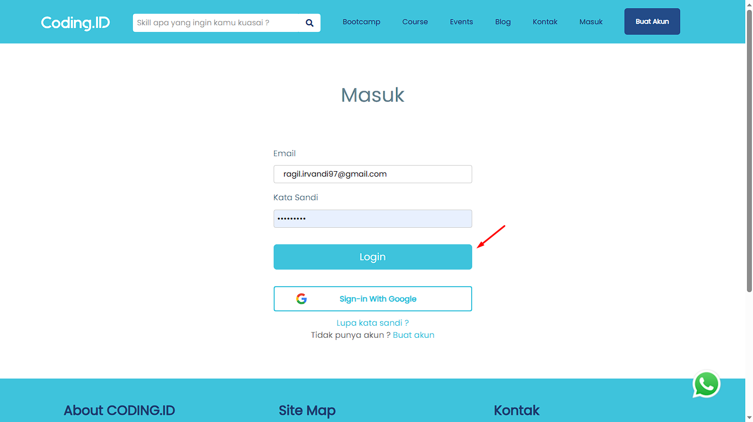



# [TCL014][User Login with valid email and with space in front password] Login

status : Passed





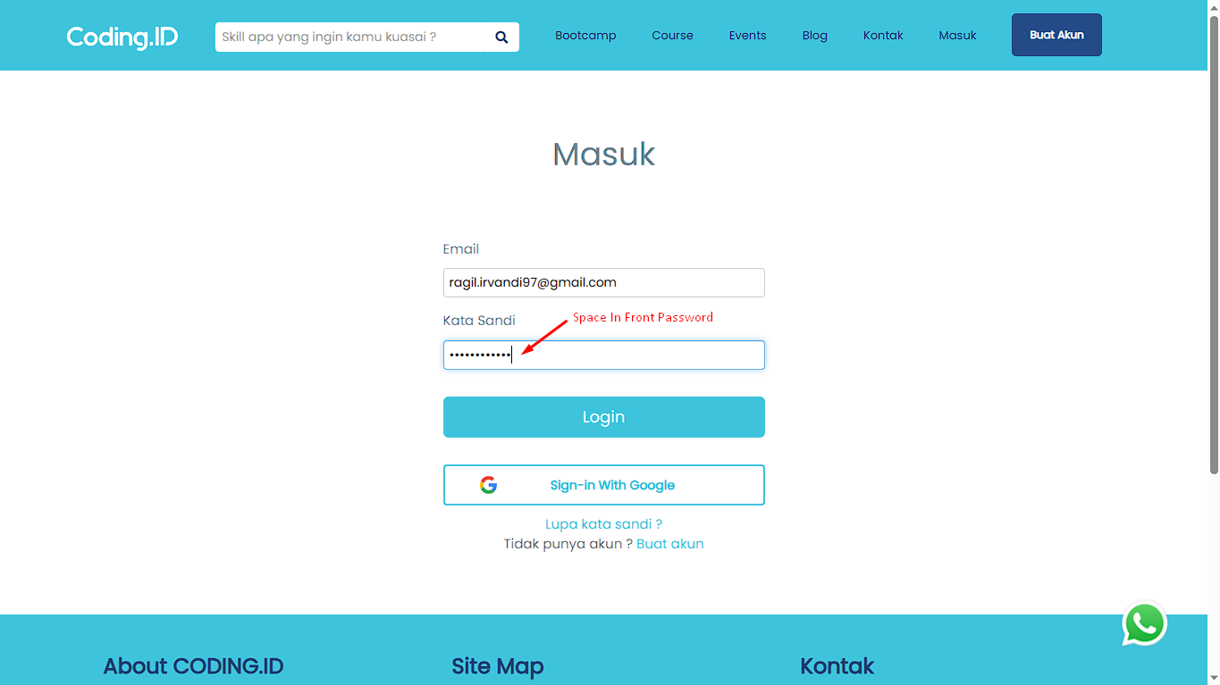





# [TCL015][User login with unregistered email and valid password] Login

status : Passed



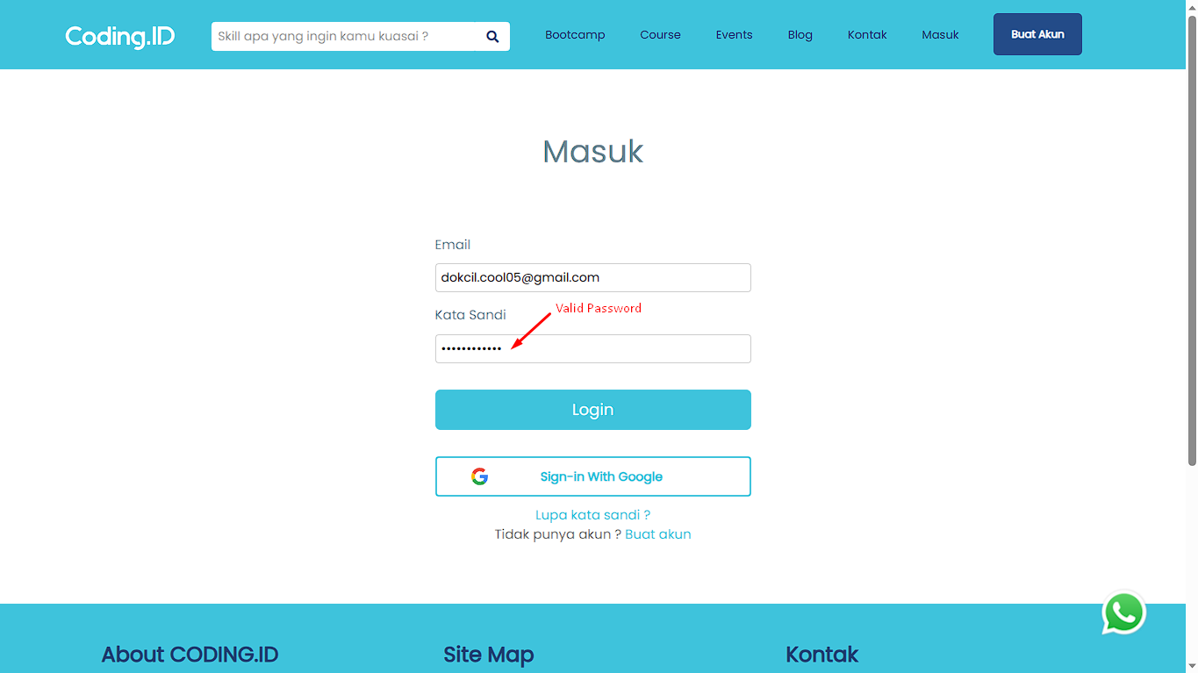

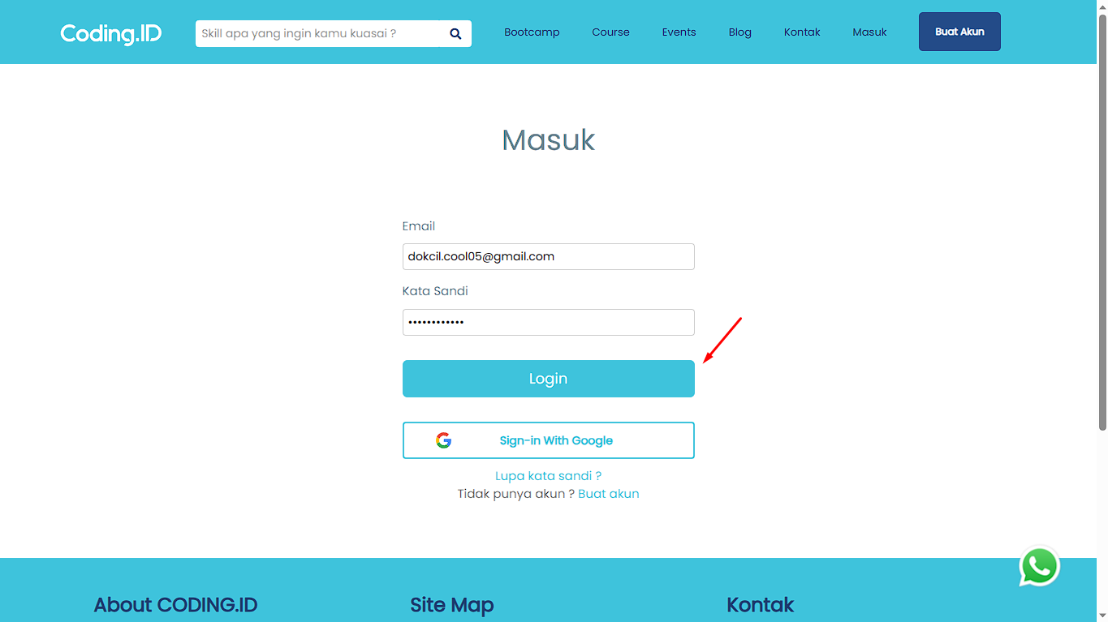

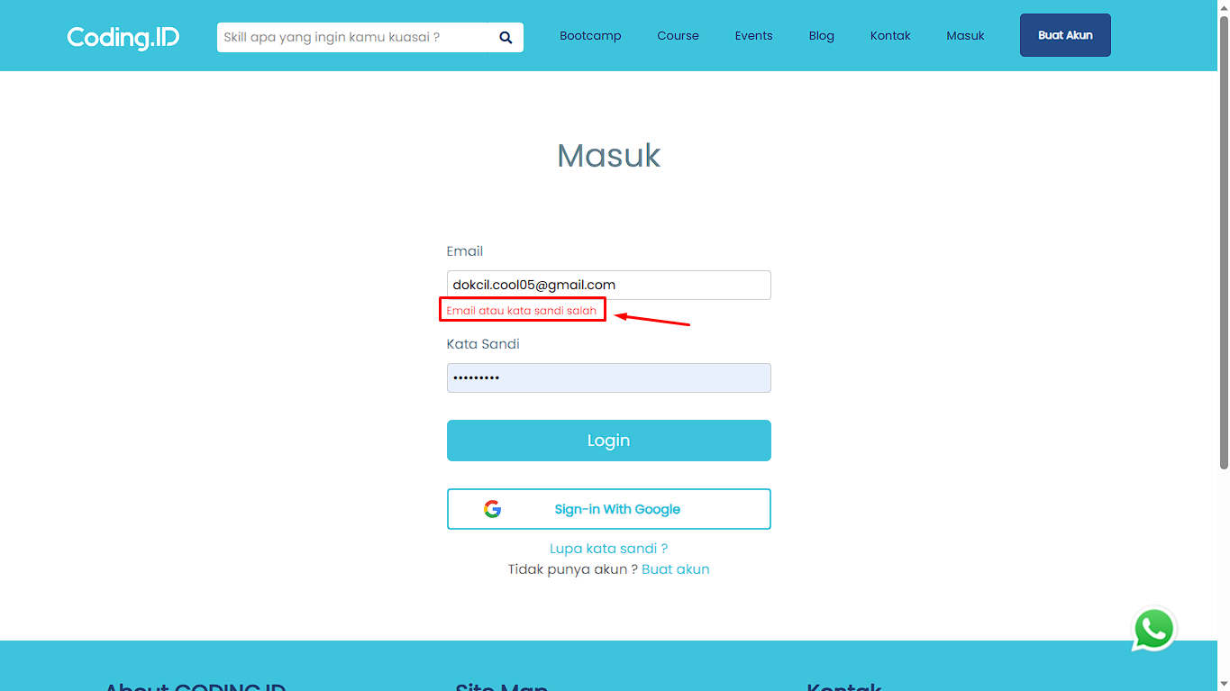

# **CHANGE PROFILE**

# [TCCP001][Test Case] CHANGE PROFILE

status : Passed

# **BUY EVENT**

# [TCE001][User add an event to cart] BUY EVENT

status : Passed

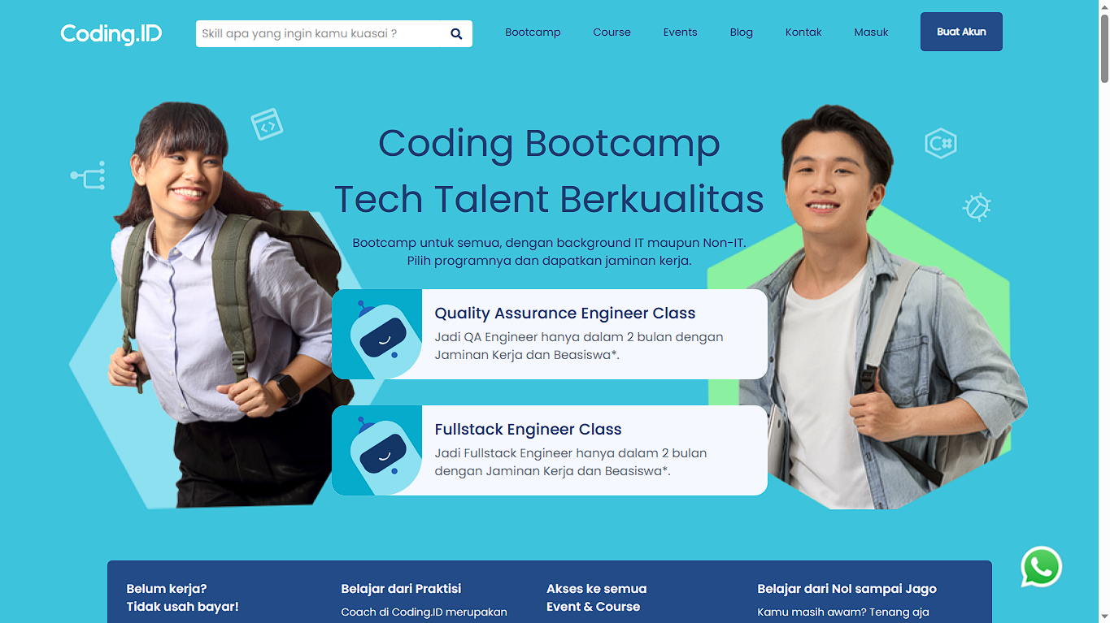

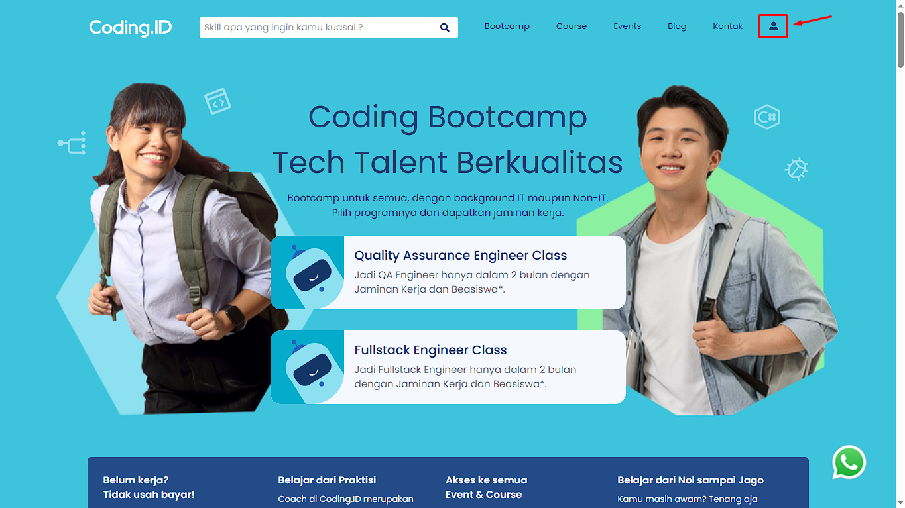

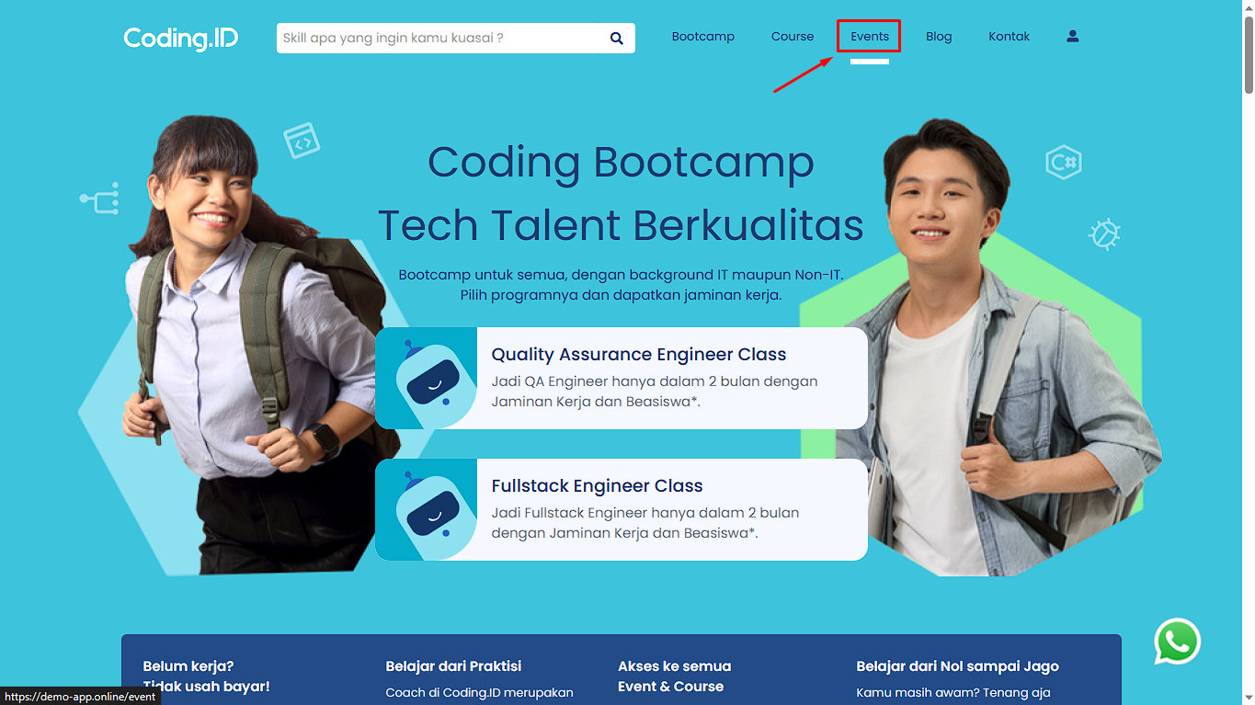

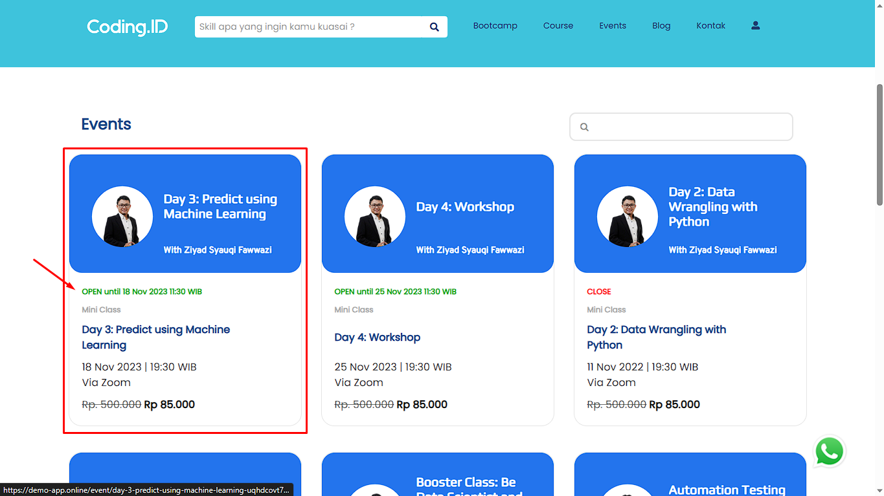

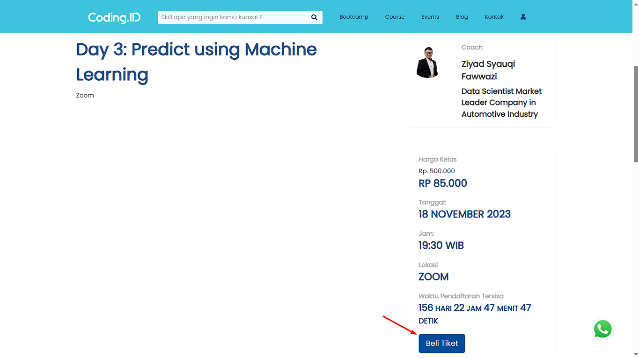

# [TCE002][User successfully makes payment until invoice appears] BUY EVENT

status : Passed











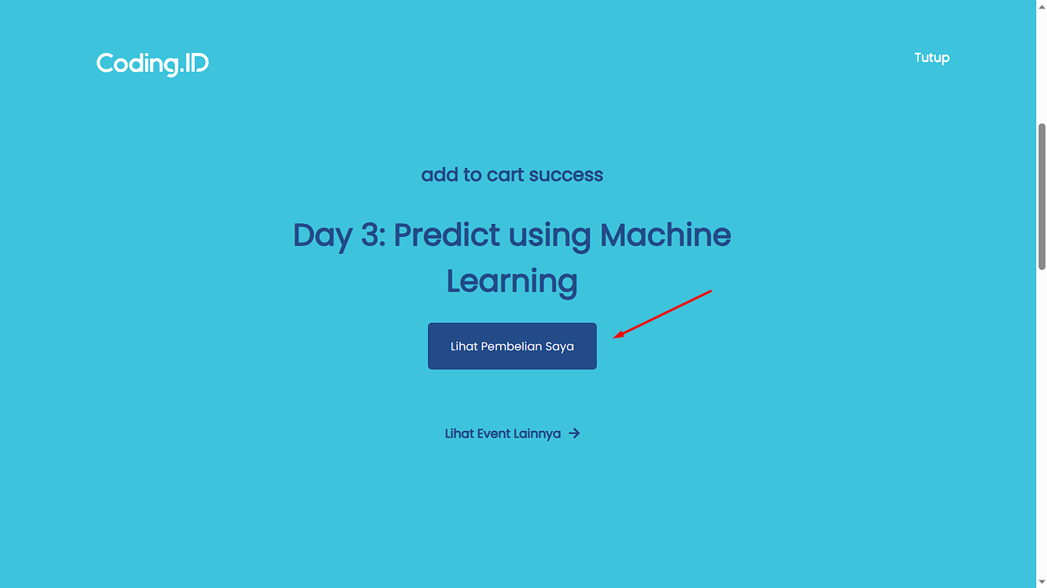

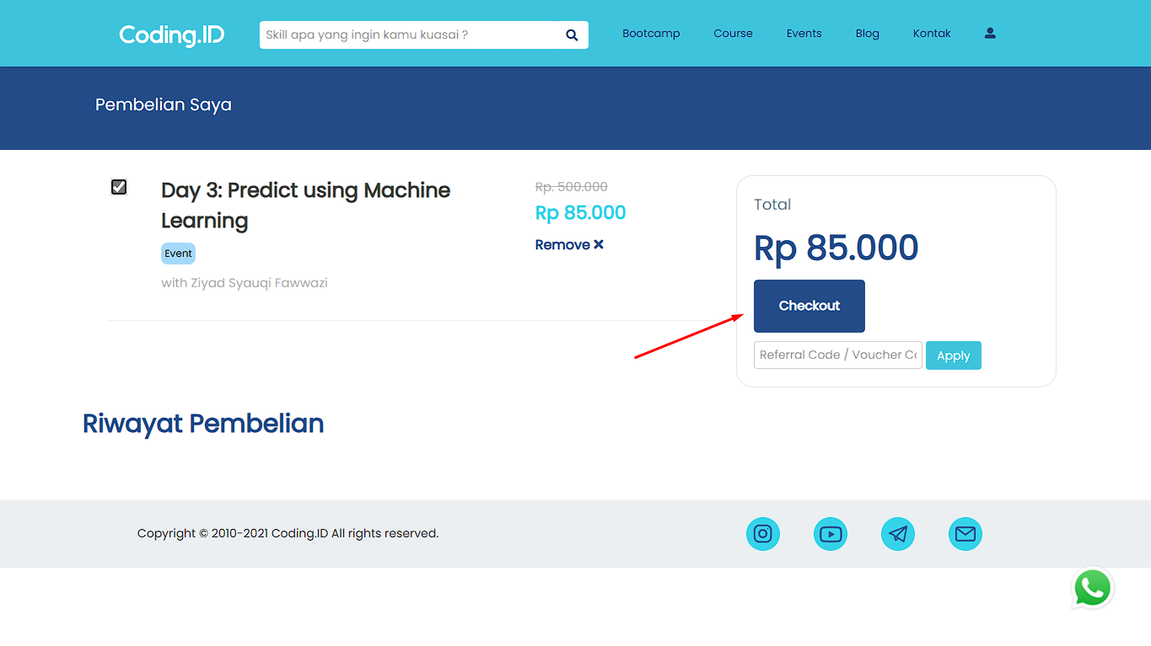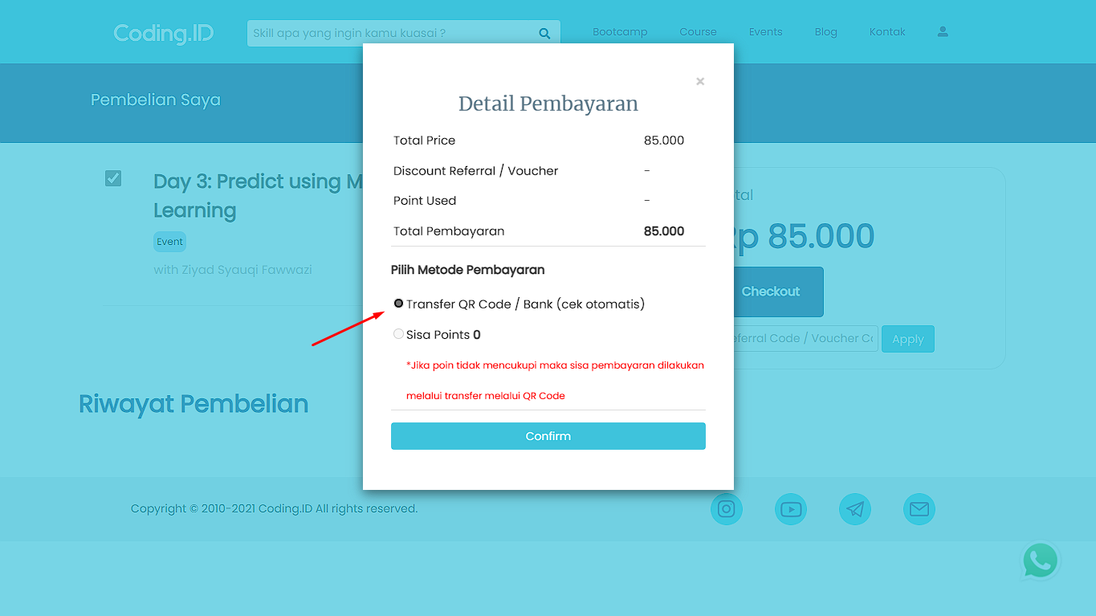

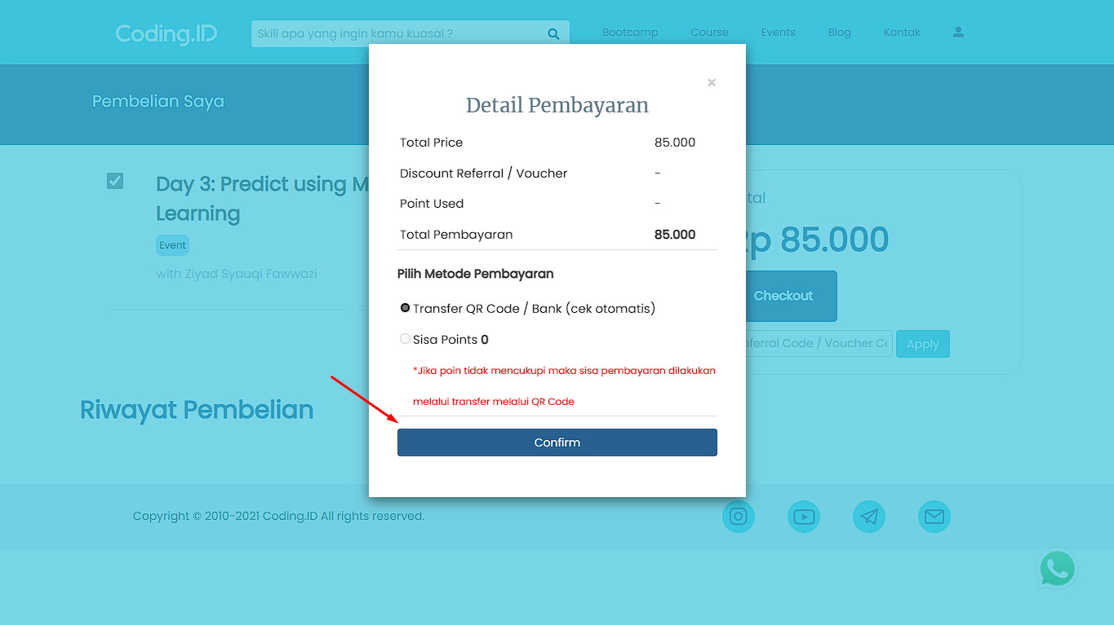

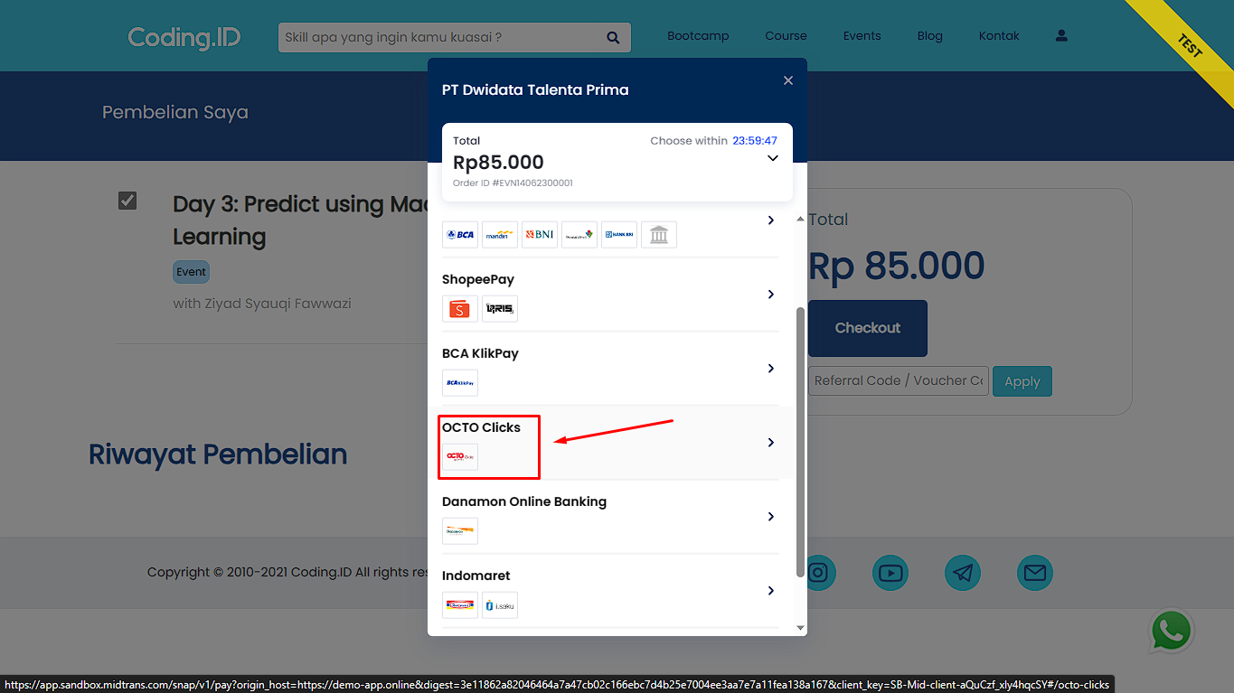

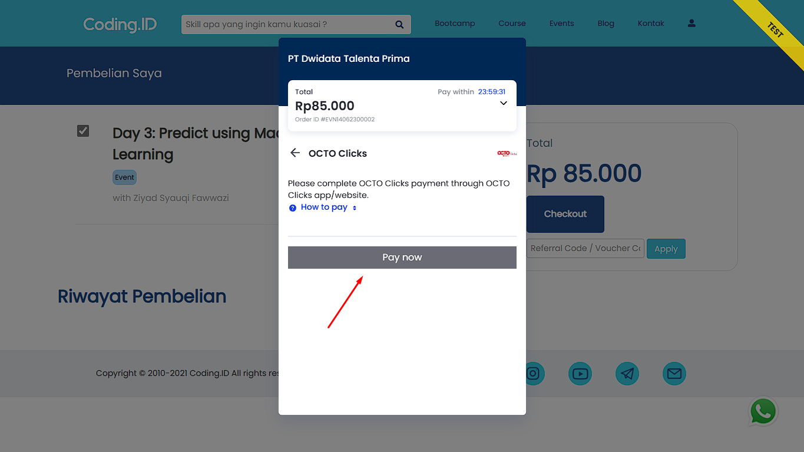

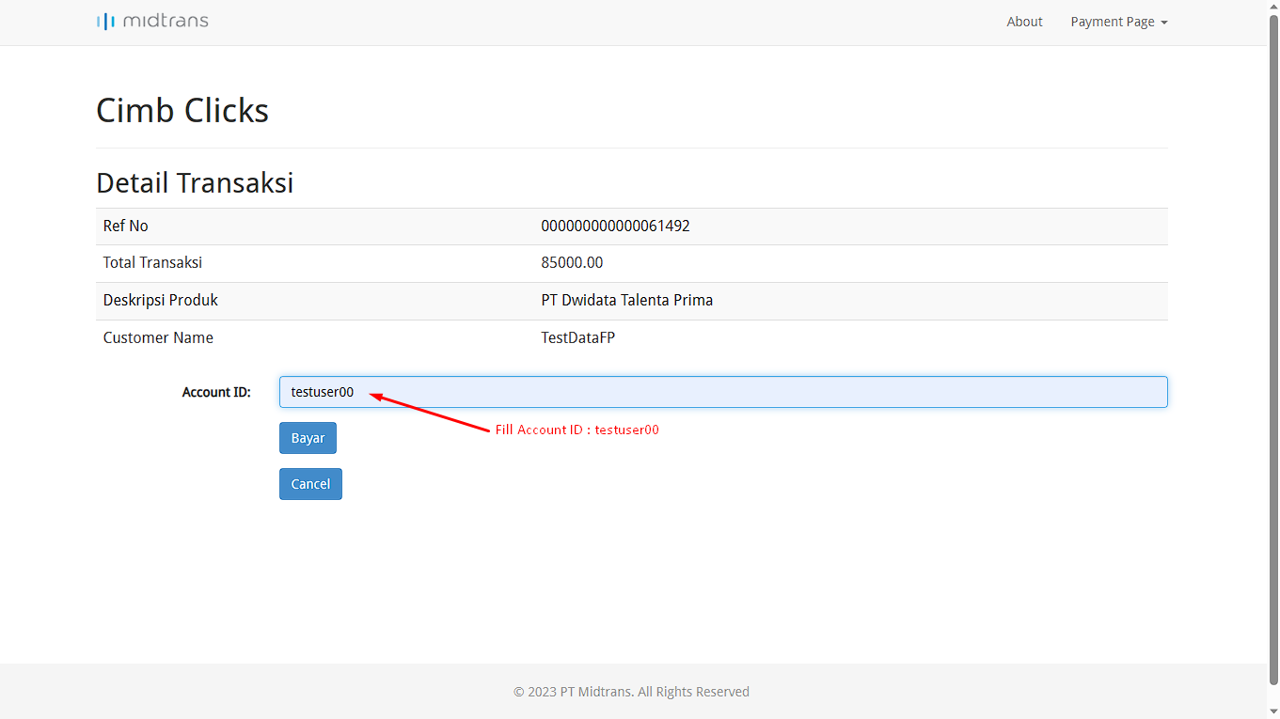

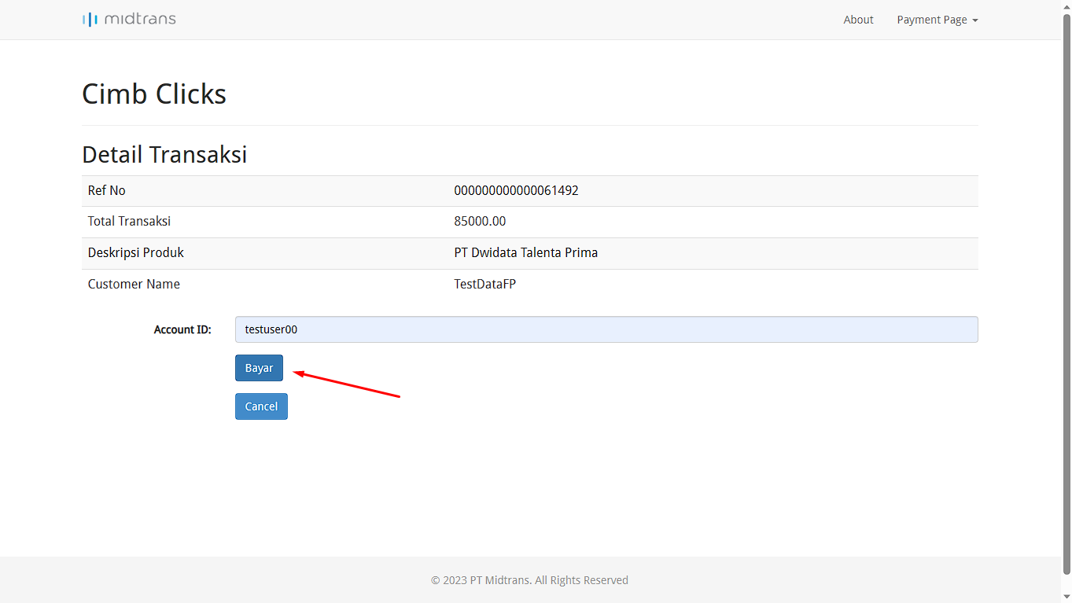

# [TCE003][User successfully add more than 1 event to the cart] BUY EVENT

status : Passed











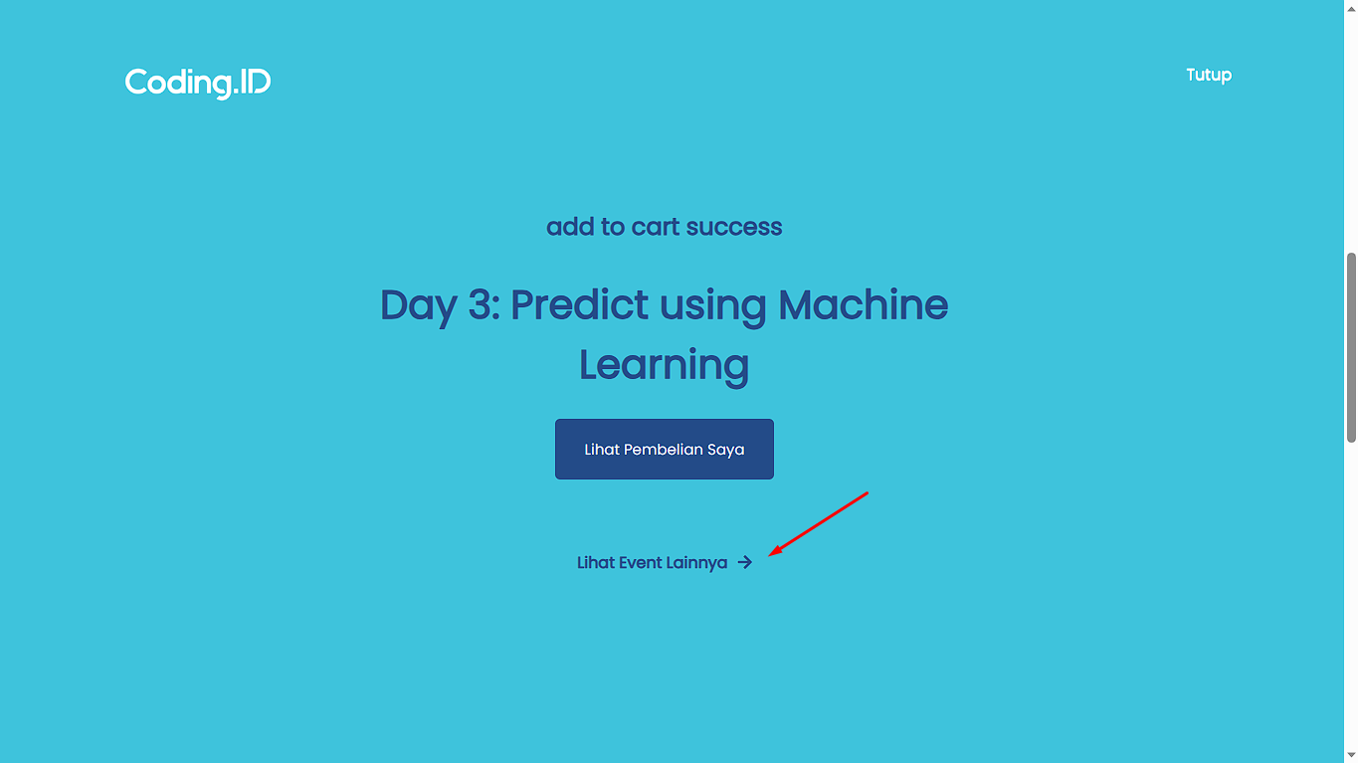

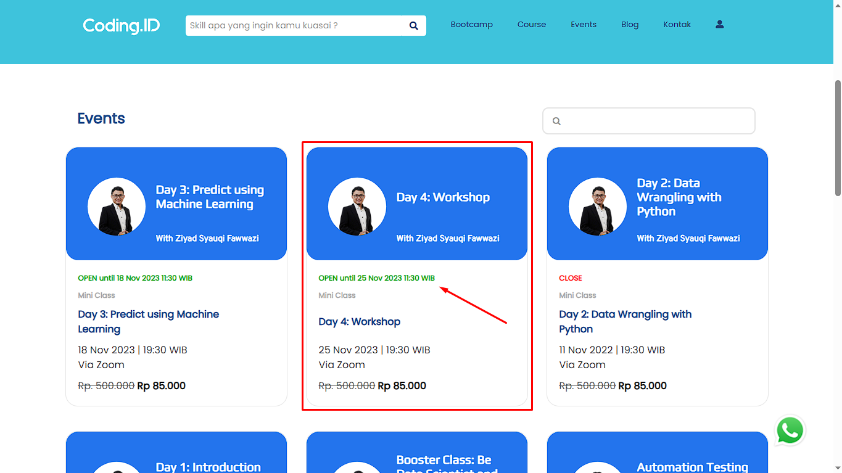

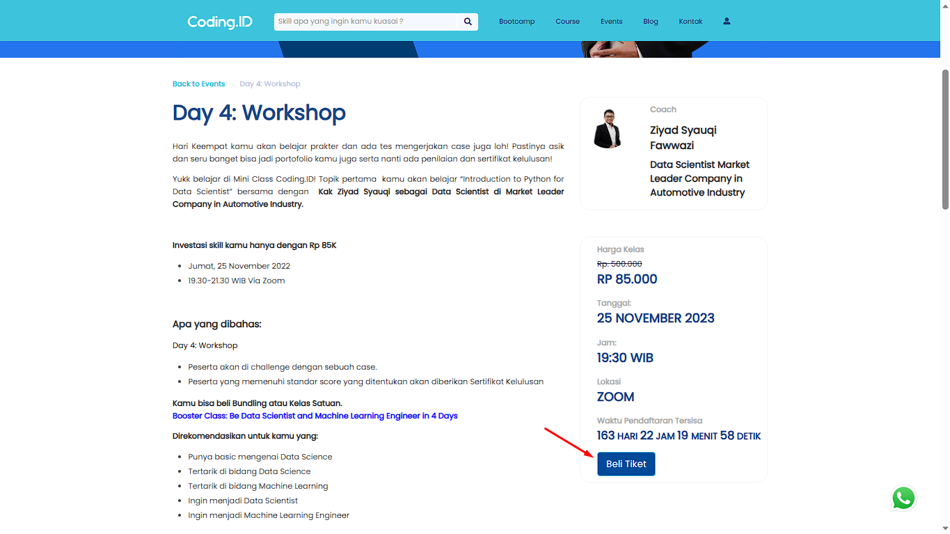

# [TCE004][Buy Event with Voucher Code] BUY EVENT

status : Passed

# [TCE005][Delete an existing event in the cart] BUY EVENT

status : Passed













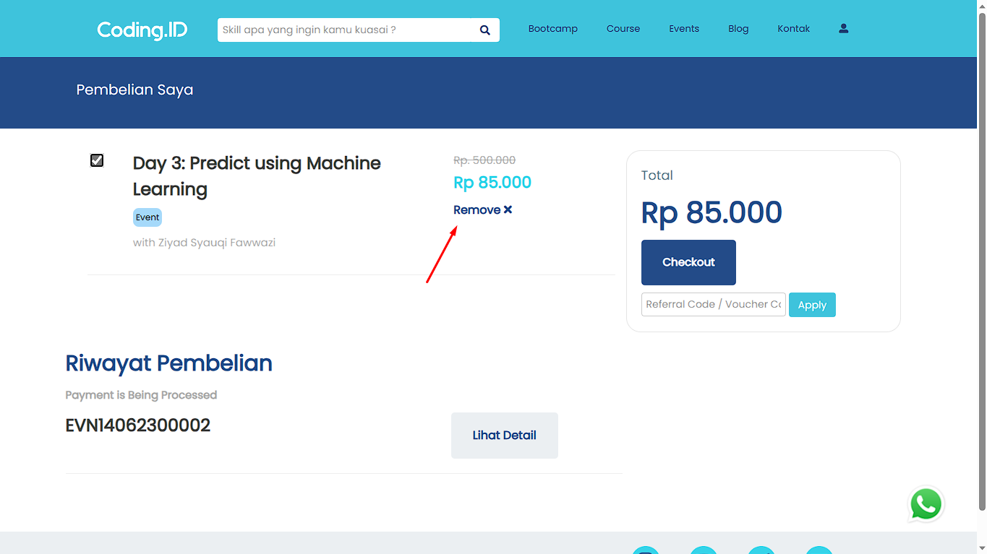

# [TCE006][That user check Cart] BUY EVENT

status : Passed





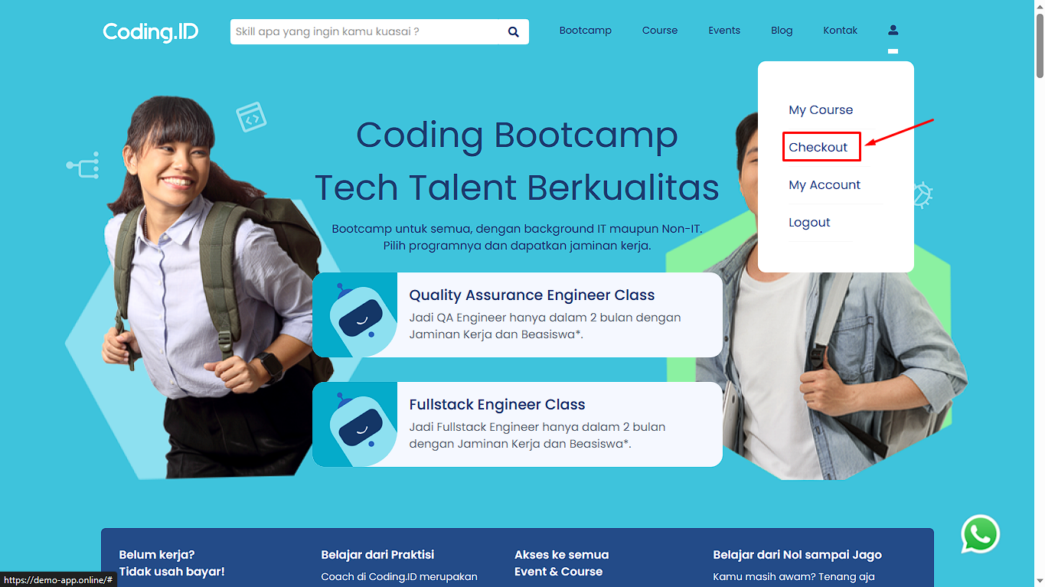

# [TCE007][Buy events without login] BUY EVENT

status : Passed



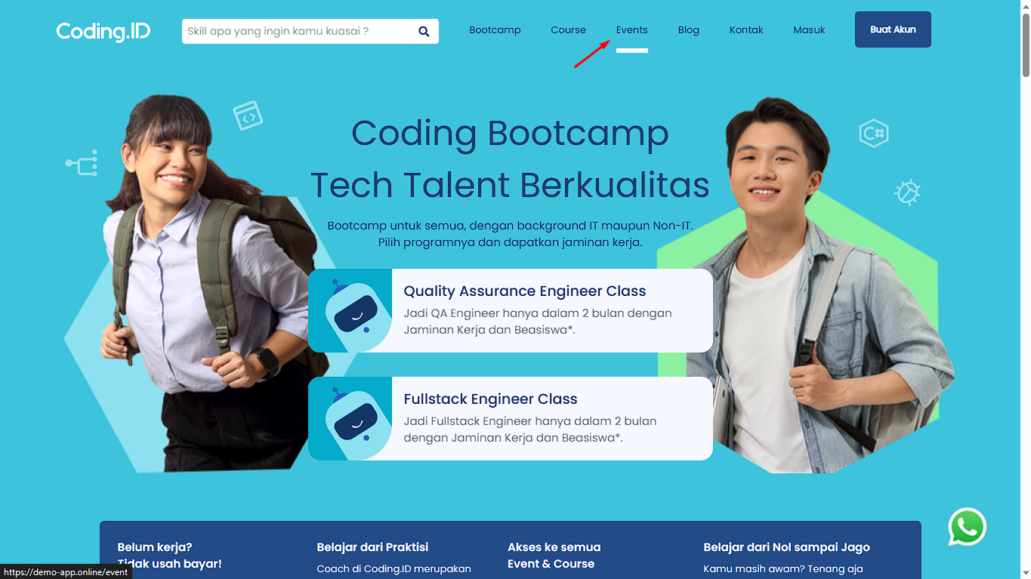

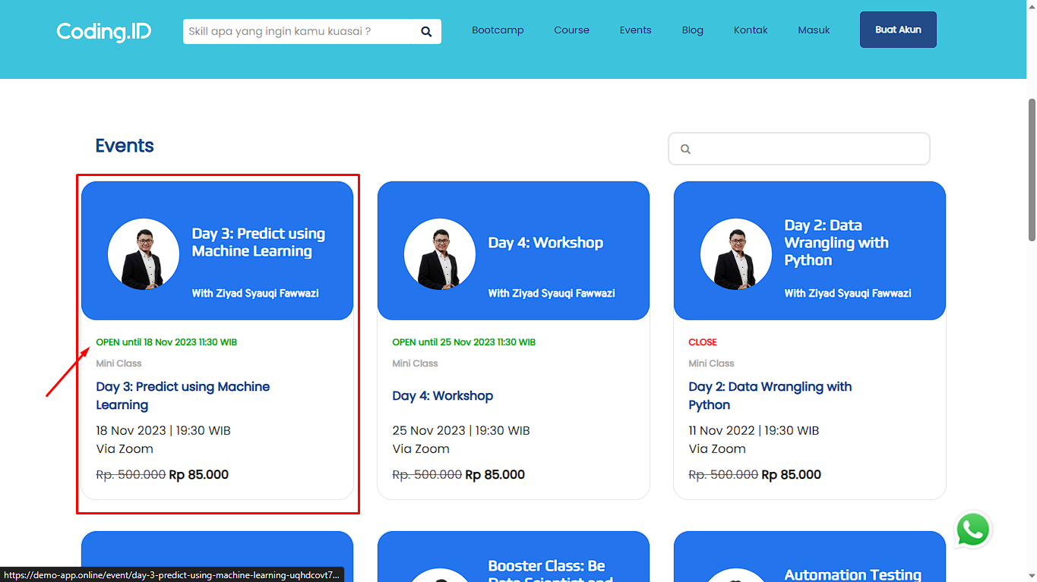

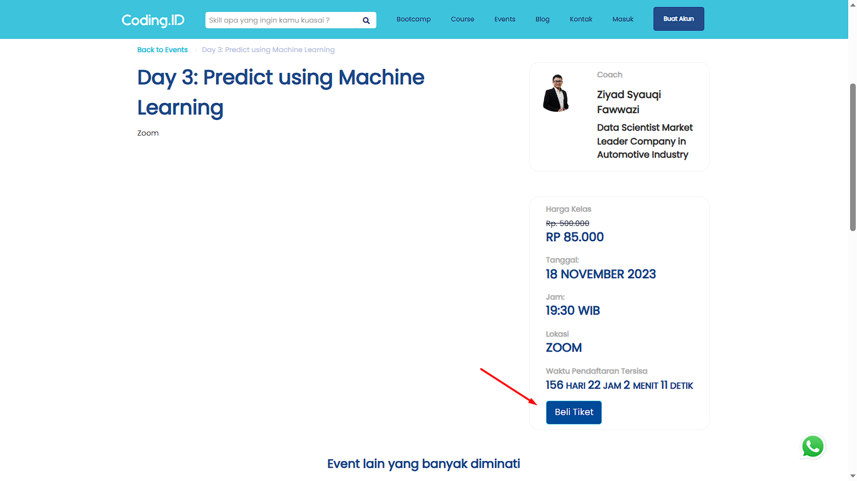

# [TCE008][User buying event when close status] BUY EVENT

status : Passed







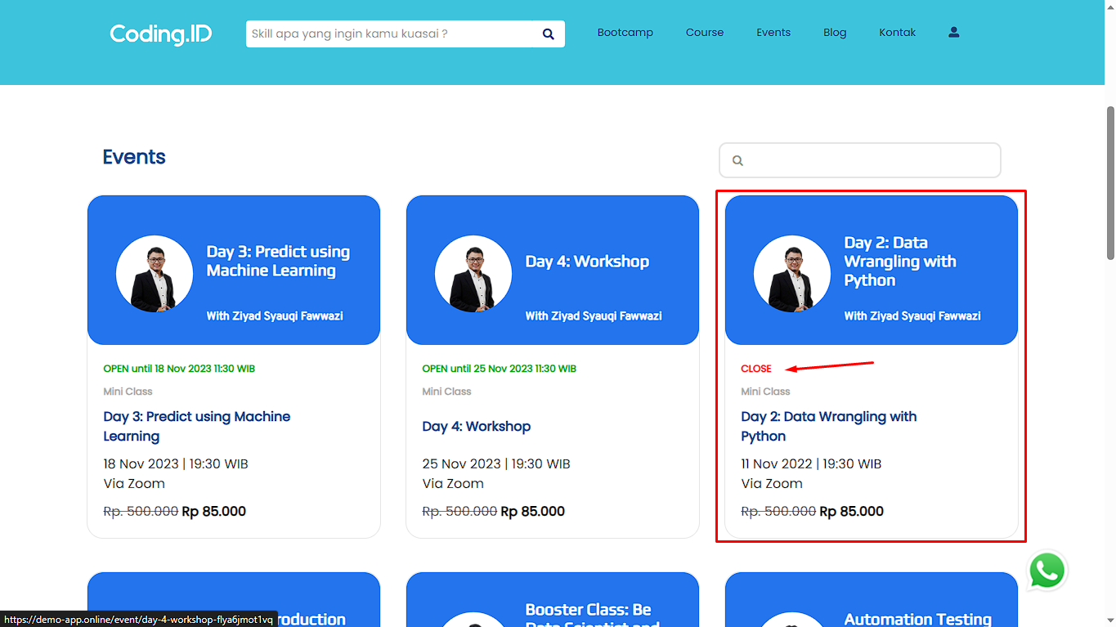

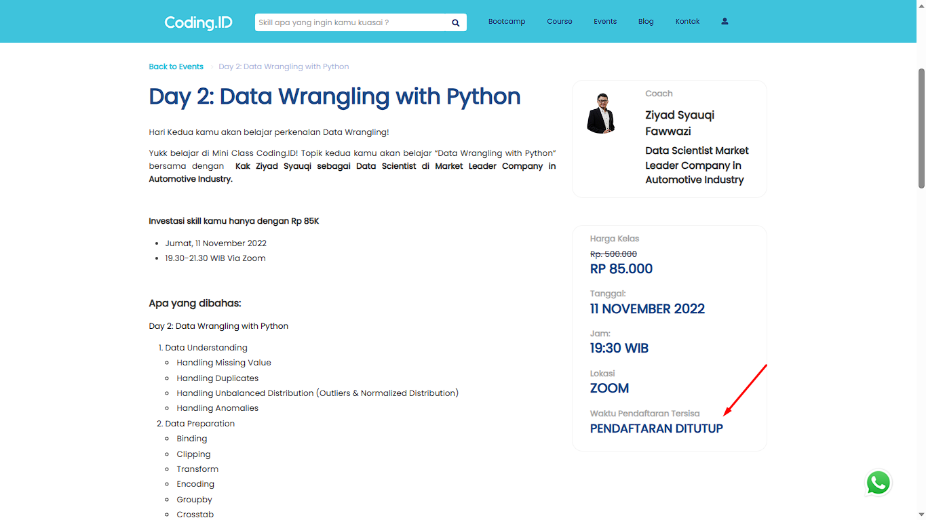

# [TCE009][Checkout events without checking mark in the event cart] BUY EVENT

status : Passed













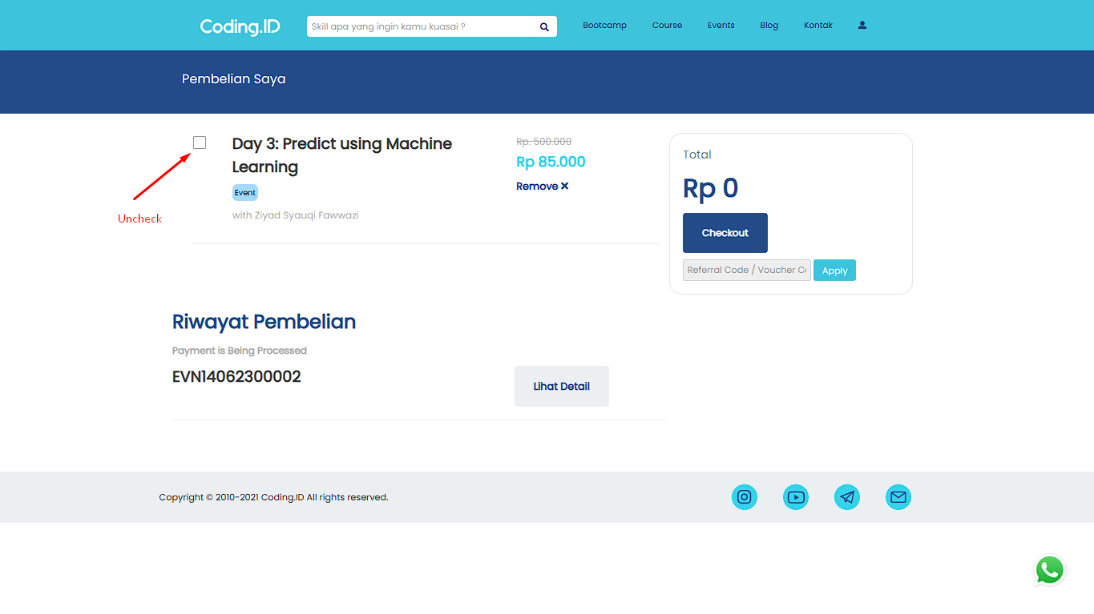

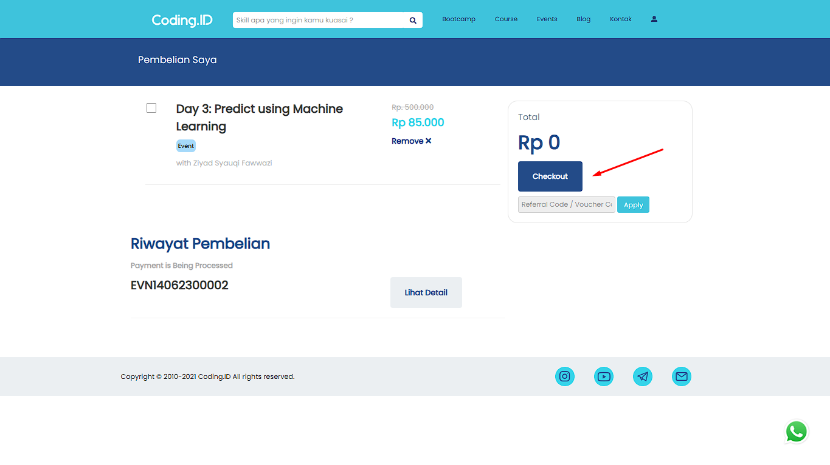

# **MOBILE**

# **REGISTER**

# [TCL-Mobile-001][User Registration Success With Valid Data] Register

status : Passed

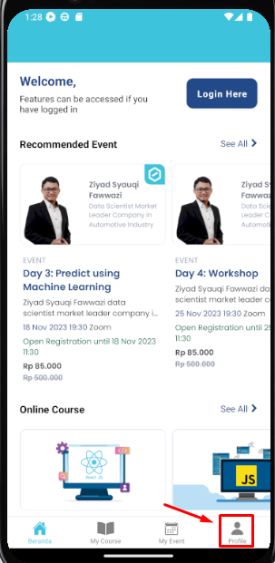

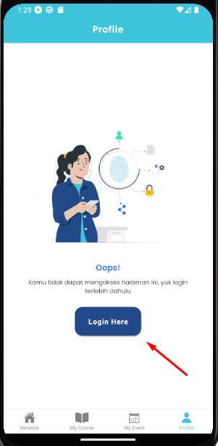

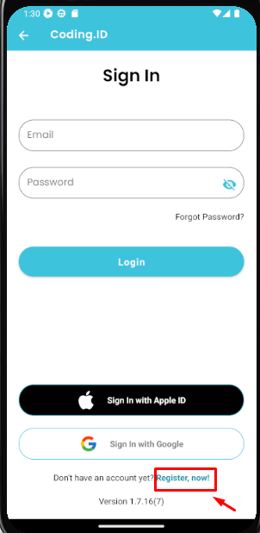

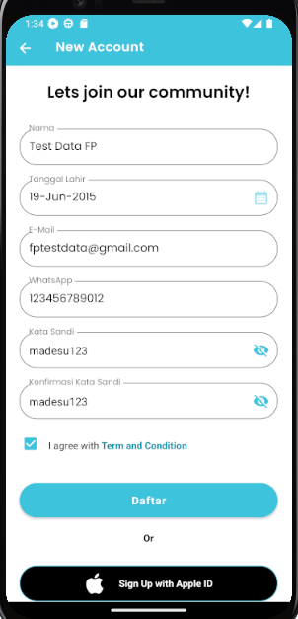

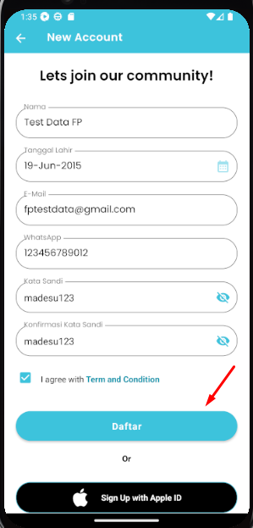

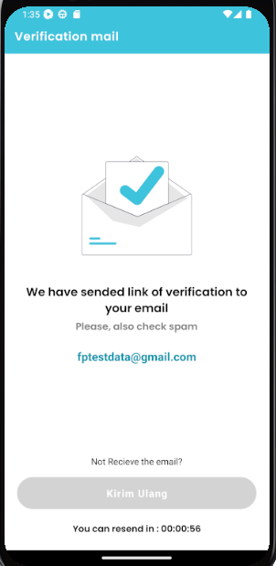

# [TCL-Mobile-002][User Registration WhatsApp With 9 Character] Register

status : Passed







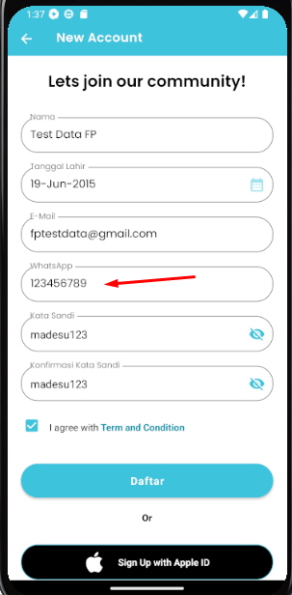





# [TCL-Mobile-003][User Registration WhatsApp With 13 Character] Register

status : Passed







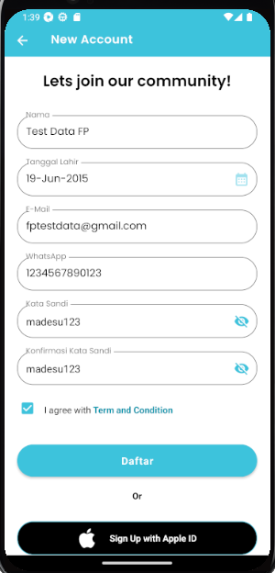







# [TCL-Mobile-004][User Registration "Kata Sandi" With 8 Character] Register

status : Passed







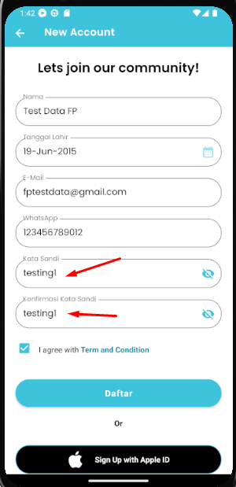





# [TCL-Mobile-005][User registration set birthday 6 years old] Register

status : Failed









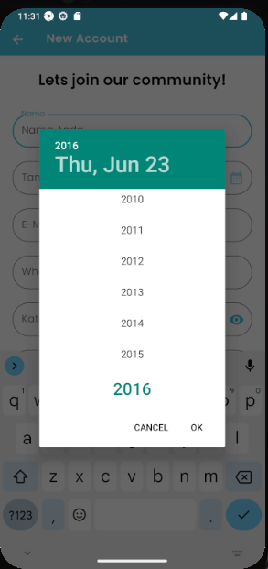

# [TCL-Mobile-006][User registration set birthday between 6 - 7 years old] Register

status : Failed







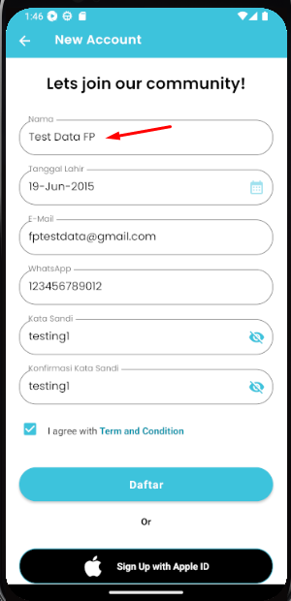



# [TCL-Mobile-007][User registration with email address using special characters] Register

status : Passed







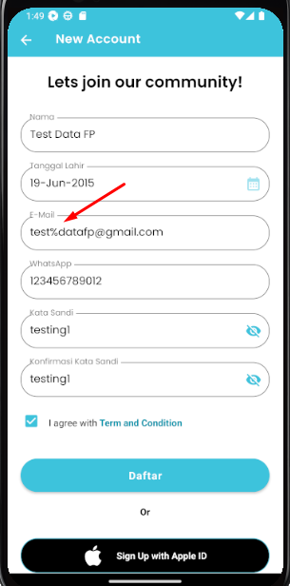



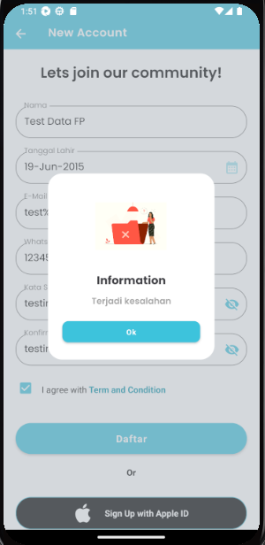

# [TCL-Mobile-008][User registration with email address using uppercase characters and number] Register

status : Passed





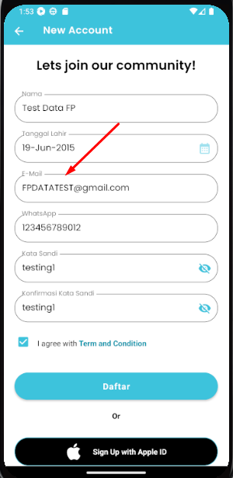





# [TCL-Mobile-009][User register with registered email] Register

status : Passed



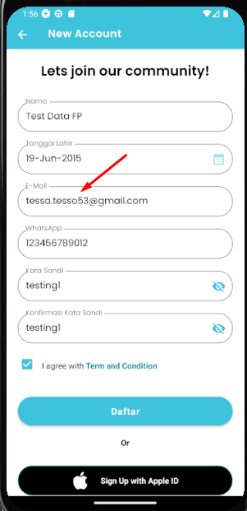





# [TCL-Mobile-010][User registration using special characters in "Nama"] Register

status : Passed







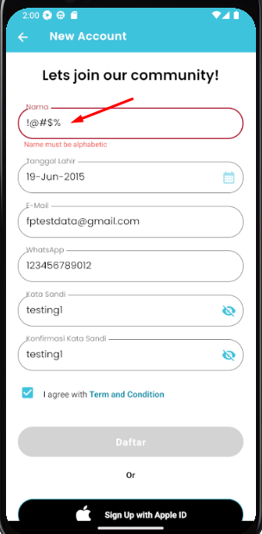



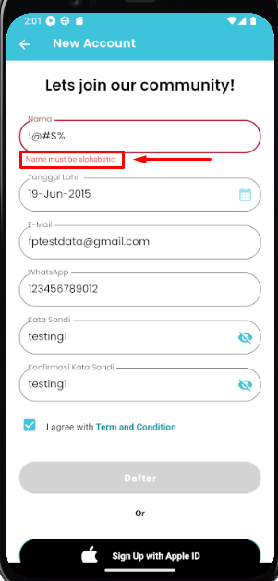

# [TCL-Mobile-011][User registration not fill in the "Nama" field] Register

status : Passed







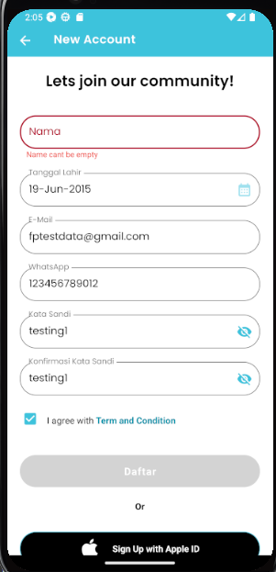





# [TCL-Mobile-012][User registration using number only in the "Nama" field] Register

status : Passed







# [TCL-Mobile-013][User registration using a combination of letters and numbers in "Nama" field] Register

status : Passed





# [TCL-Mobile-014][User registration does not fill in the email field] Register

status : Passed







# [TCL-Mobile-015][User registration not using "@" in email] Register

status : Passed







# [TCL-Mobile-016][User registration in the email field with domain at the beginning] Register

status : Passed

# [TCL-Mobile-017][User registration by using a space at the beginning in the Email field] Register

status : Passed

# [TCL-Mobile-018][User registration with WhatsApp number not filled] Register

status : Passed

# [TCL-Mobile-019][User registration with "Date of Birth" not fill] Register

status : Passed

# [TCL-Mobile-020][User registration in the WhatsApp column fills in the number exceeding the maximum requirement, which is more than 13] Register

status : Passed

# [TCL-Mobile-021][Register without fill the field] Register

status : Passed

# [TCL-Mobile-022][User registration without confirm terms and conditions checkbox] Register

status : Passed

# [TCL-Mobile-023][User registration by differentiating password confirmation with password] Register

status : Passed

# [TCL-Mobile-024][User registration leaving the "Kata Sandi" field unfilled] Register

status : Passed

# [TCL-Mobile-025][User registration leaving the "Konfirmasi Kata Sandi" field unfilled] Register

status : Passed

# **LOGIN**

# [TCL-Mobile-001][Login With Valid Data] Login

status : Passed

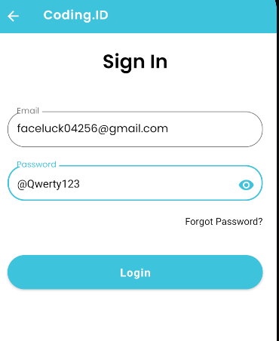

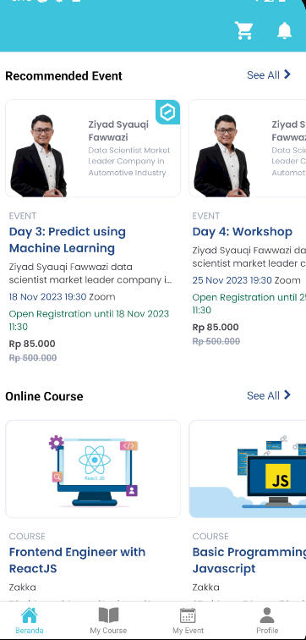

# [TCL-Mobile-002][Login With UnRegistered Email] Login

status : Passed

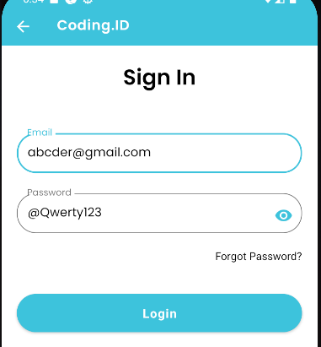

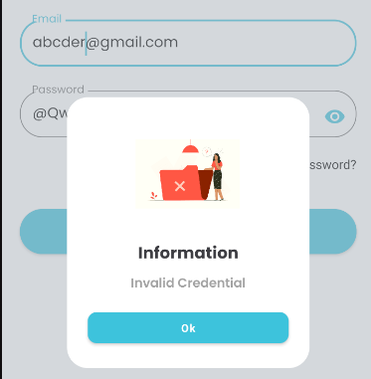

# [TCL-Mobile-003][Login With Incorect Password] Login

status : Passed

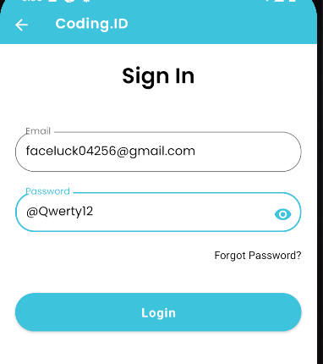

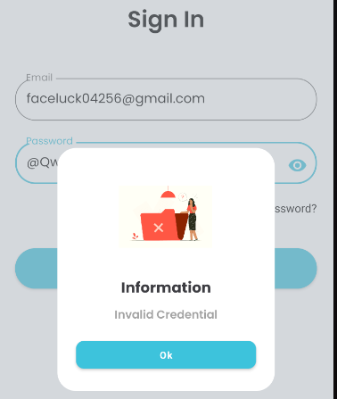

# [TCL-Mobile-004][Login With Empty Email and Password] Login

status : Passed

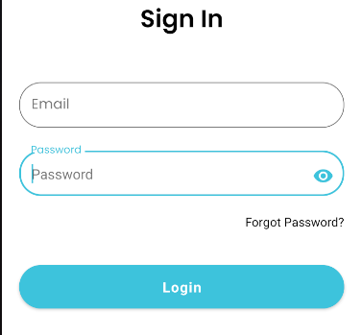

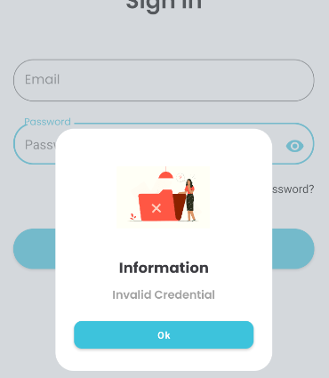

# **CHANGE PROFILE**

# [TCUP001][Update Profile With Valid Data] Change Profile

status : Passed

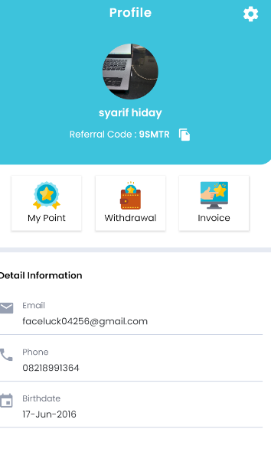

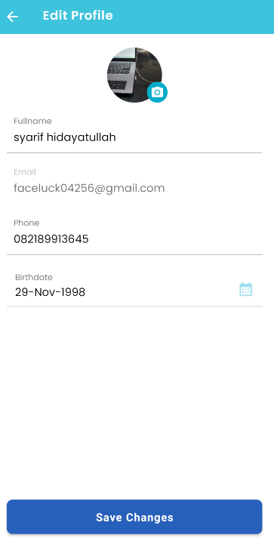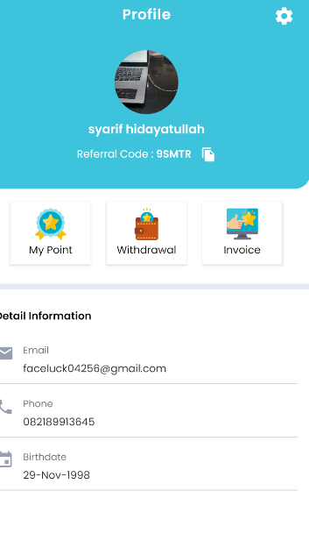

# [TCUP002][trying To Update Email] Change Profile

status : Passed



# [TCUP003][Update Profile Picture take from Camera] Change Profile

status : Passed

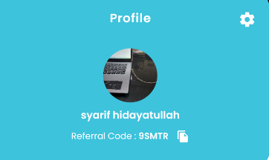

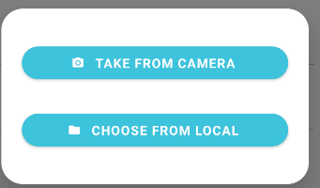

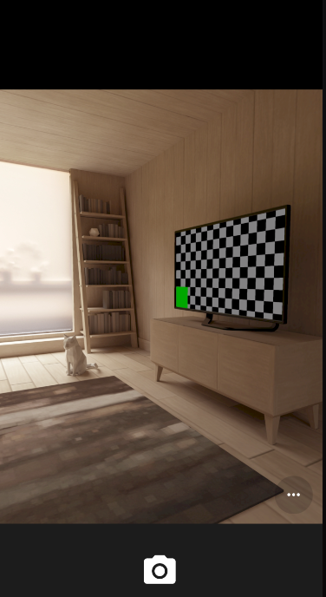

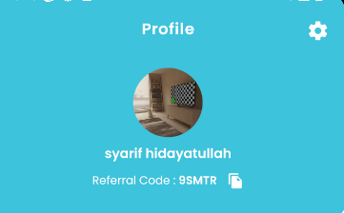

# [TCUP004][Update Profile Picture take from Local Drive] Change Profile

status : Passed





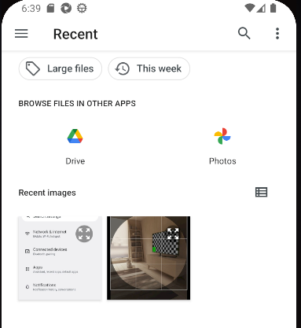

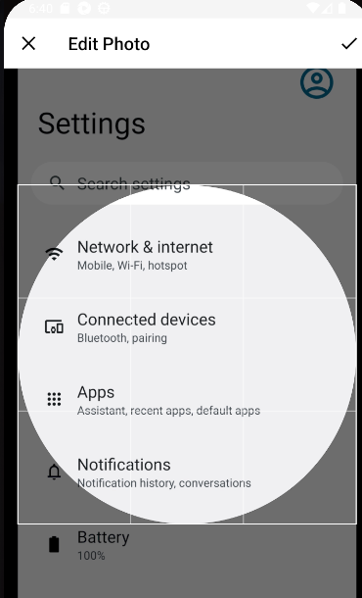

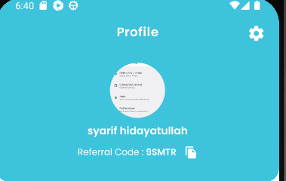

# [TCUP005][Update Profile by using Minimum Character Length for Phone Number ( 9 character )] Update Profile

status : Passed

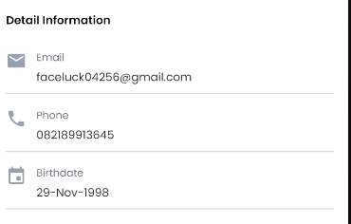

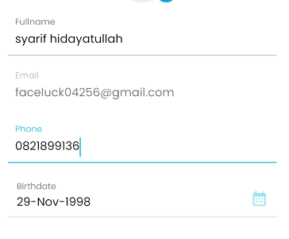

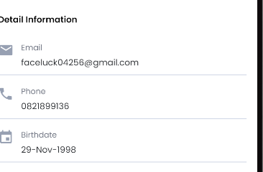

# [TCUP006][Update Profile by using Maximum Character Length for Phone Number ( 13 Character )] Update Profile

status : Passed



# 

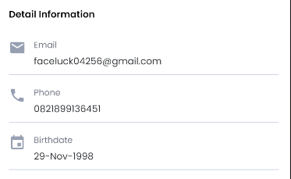

# [TCUP007][Update Profile birthdate using Minimum Age Requirement 6 years old] Update Profile

status : Failed



maximum date is 22 June 2016

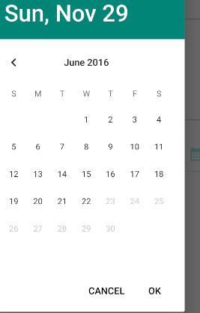

# [TCUP008][Update Profile birtdate Over 6 years old] Update Profile

status : Passed

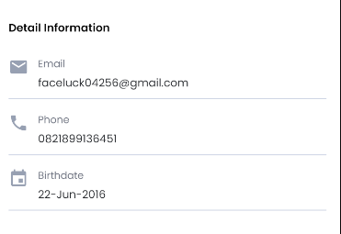

# [TCUP009][Update Full Name Only] Update Profile

status : Passed

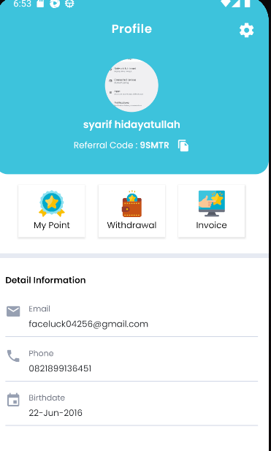

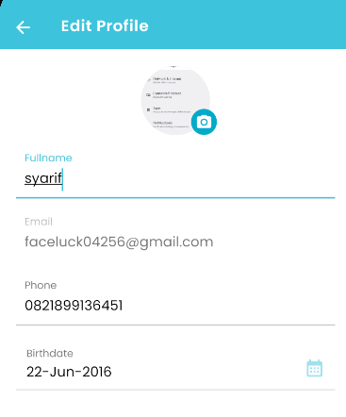

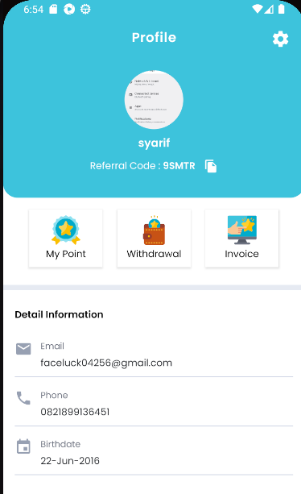

# [TCUP0010][Cancel Update after tap "Save changes" to continue Change profile ] Update Profile

status : Passed



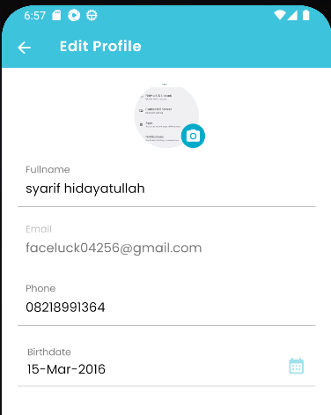

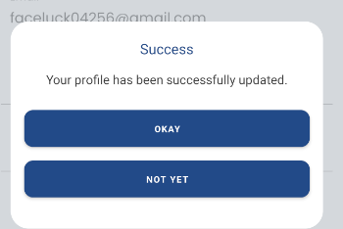 Tap “Not Yet” and press back

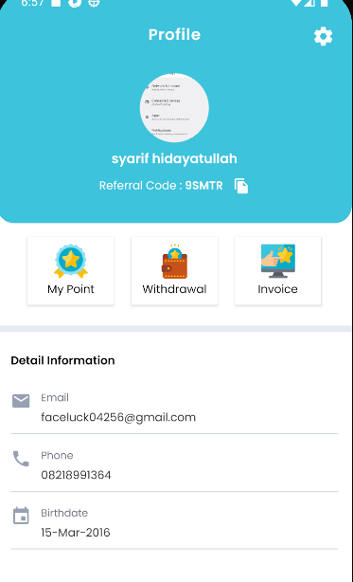

# [TCUP0011][Cancel Update Profile by pressing back button] Update Profile

status : Passed



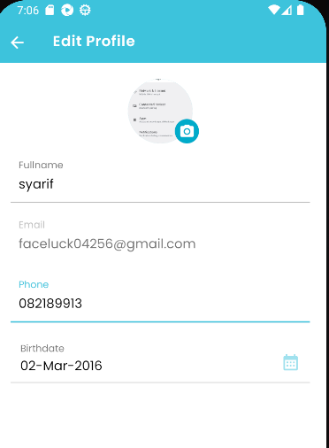 Then Press Back



# [TCUP0012][Update full Name by adding number] Update Profile

status : Passed

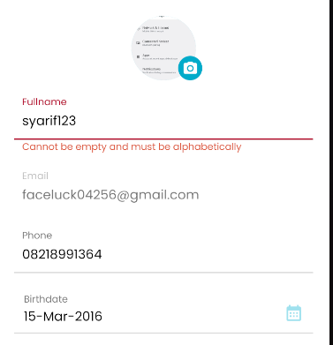

# [TCUP0013][Update full Name by adding Special Characters] Update Profile

status : Passed

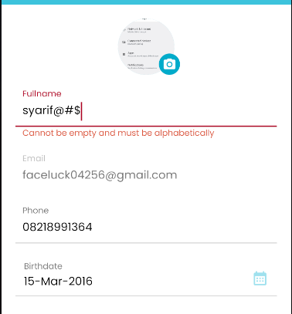

# [TCUP0014][Leaving full name Empty] Update Profile

status : Passed

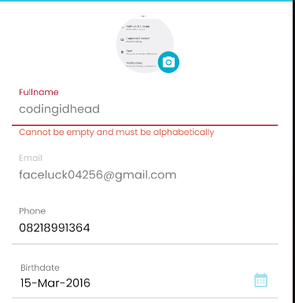

# [TCUP0015][Update profile picture with files not images] Update Profile

status : Passed



User cannot select files other than Image File

# [TCUP0016][Cancel Take Profile Picture after take a picture from camera] Update Profile

status : Passed

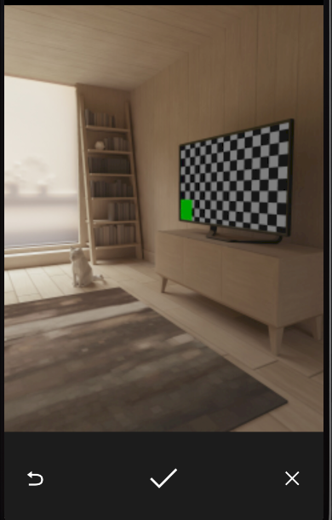 tap “ X “

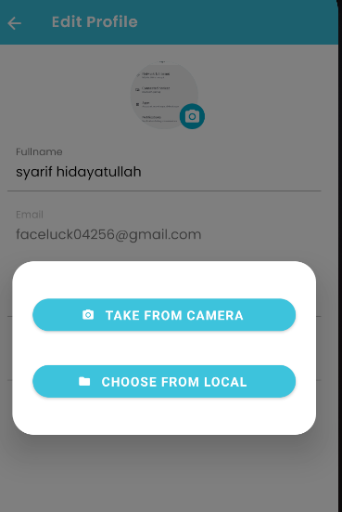

# [TCUP0017][leave phone number Empty] Update Profile

status : Passed

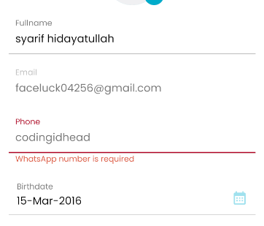

# [TCUP0018][Update phone number under minimun requirment (8-digits] Update Profile

status : Failed

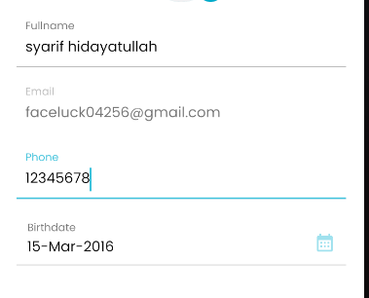

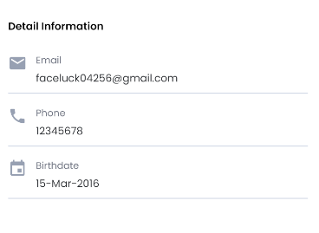

# 

# 

# [TCUP0019][Update Phone Number with over requirment characters (14-digits] Update Profile

status : Passed

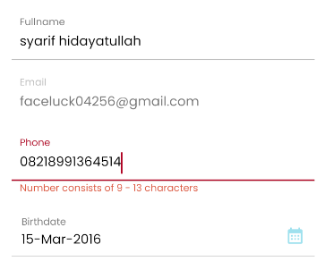

# [TCUP020][Update Phone Number by adding Alphabet] Update Profile

status : Passed

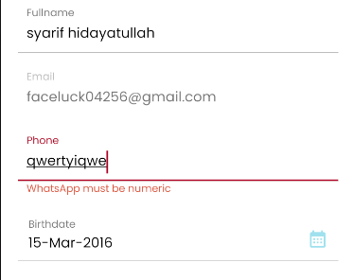

# [TCUP021][Update Phone Number by adding Special Characters] Update Profile

status : Passed

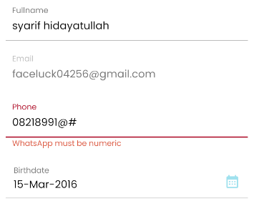

# [TCUP022][Update Phone Number by adding space beetwen numbers] Update Profile

status : Passed

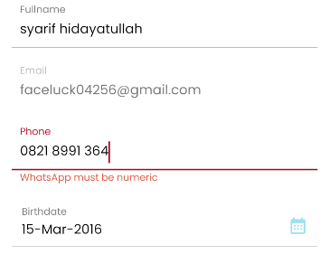

# [TCUP023][Leave field birthdate empty] Update Profile

status : Passed

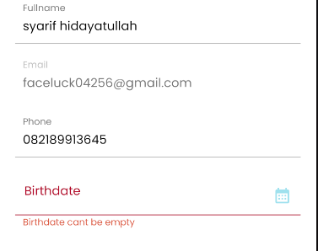

# [TCUP024][Update Profile with age under 6 years old] Update Profile

status : Falied



# **API**

# **LOGIN**

# [TCL-API-001][Login API With Valid Data] API Login

status : Passed

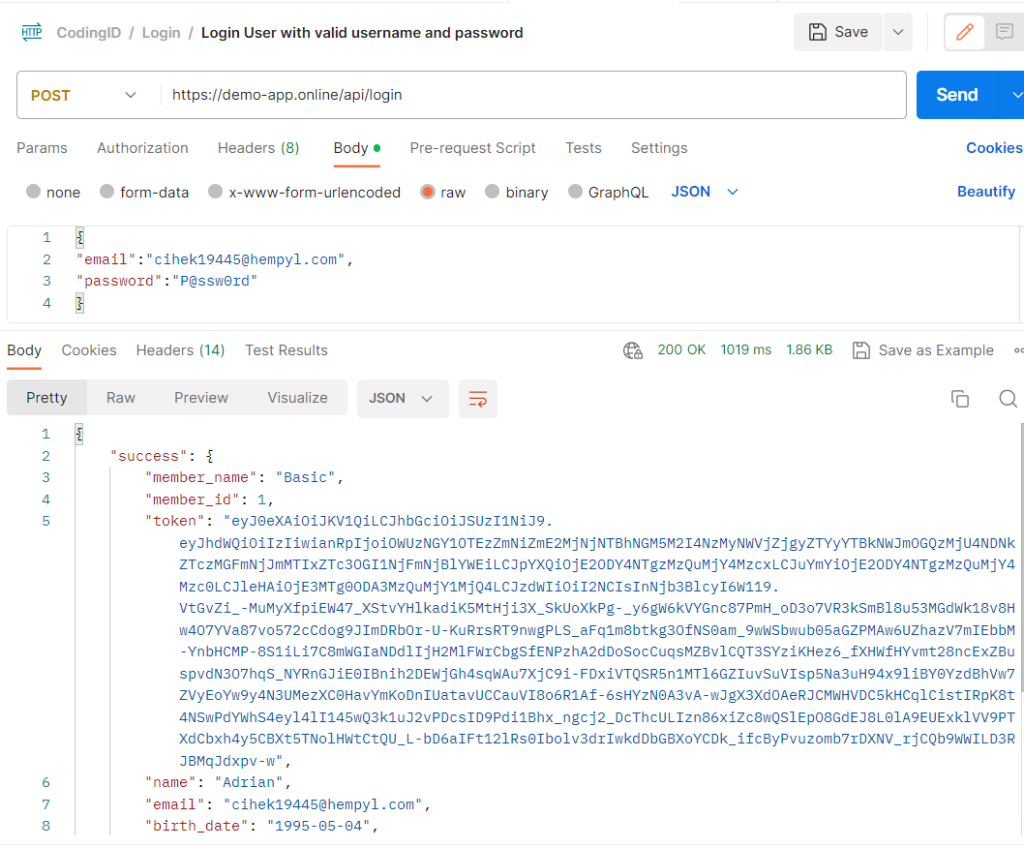

# [TCL-API-002][Login API With Invalid Username] API Login

status : Passed

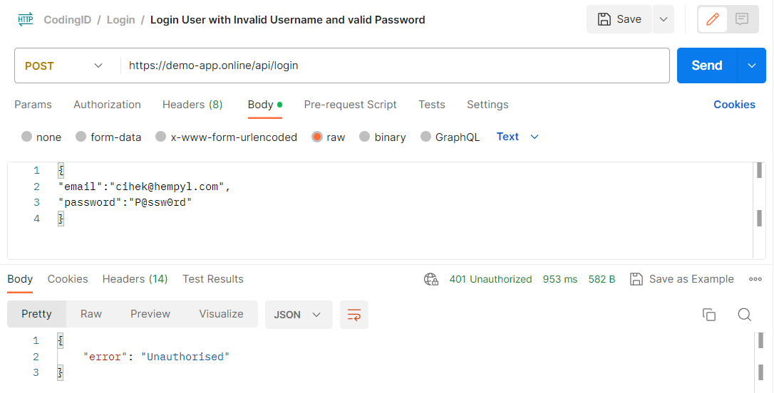

# [TCL-API-002][Login API With Incorrect Password] API Login

status : Passed

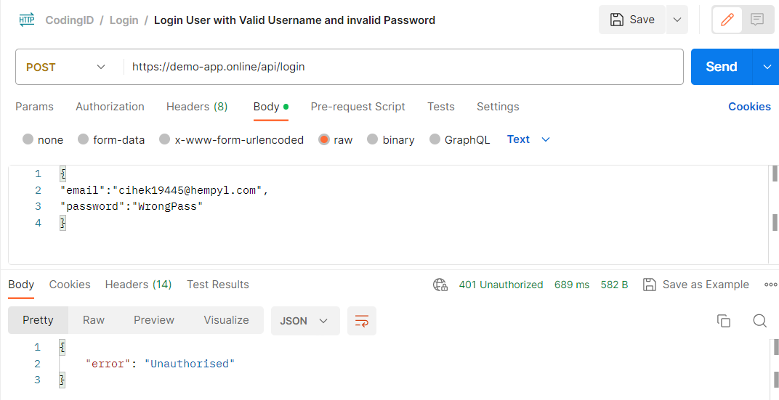

# [TCL-API-004][Login API Missing Username] API Login

status : Passed

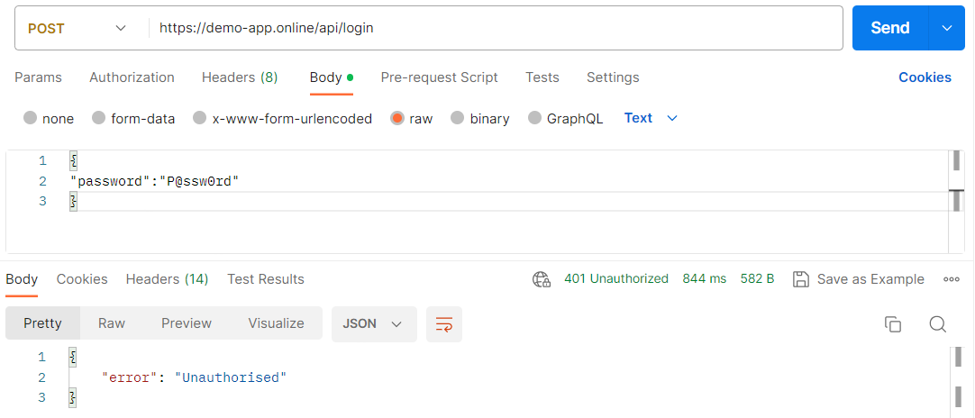

# [TCL-API-005][Login API Missing Password] API Login

status : Passed

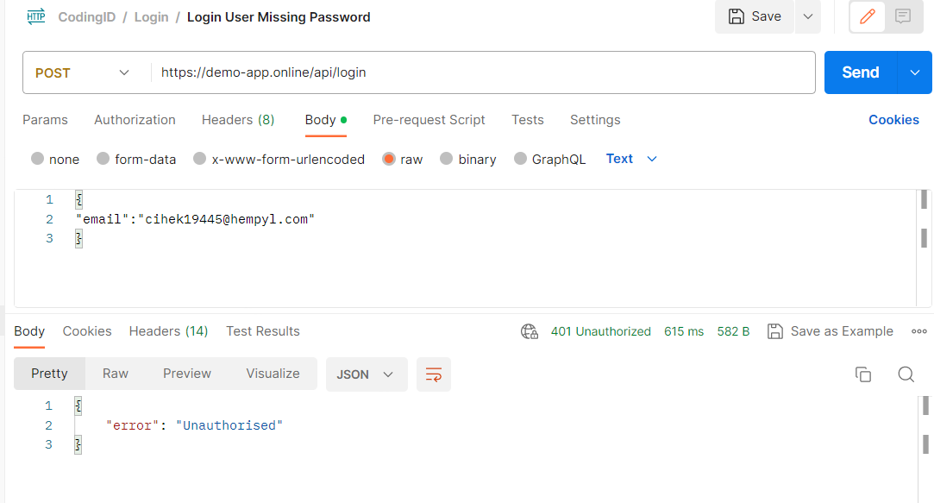

# [TCL-API-006][Post API without Username and Password] API Login

status : Passed

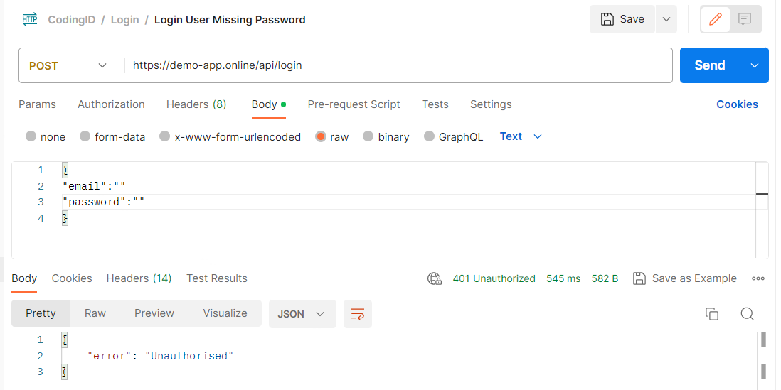

# 

# **UPDATE PROFILE**

# [TCUP-API-001][Update all Profile Data] API

status : Passed

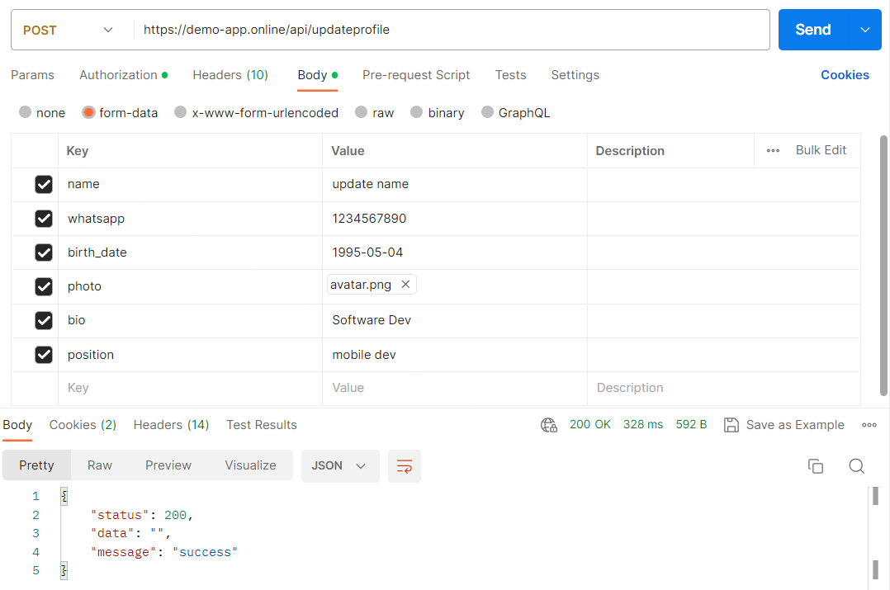

# [TCUP-API-002][Just Update Profile Name] API

status : Passed

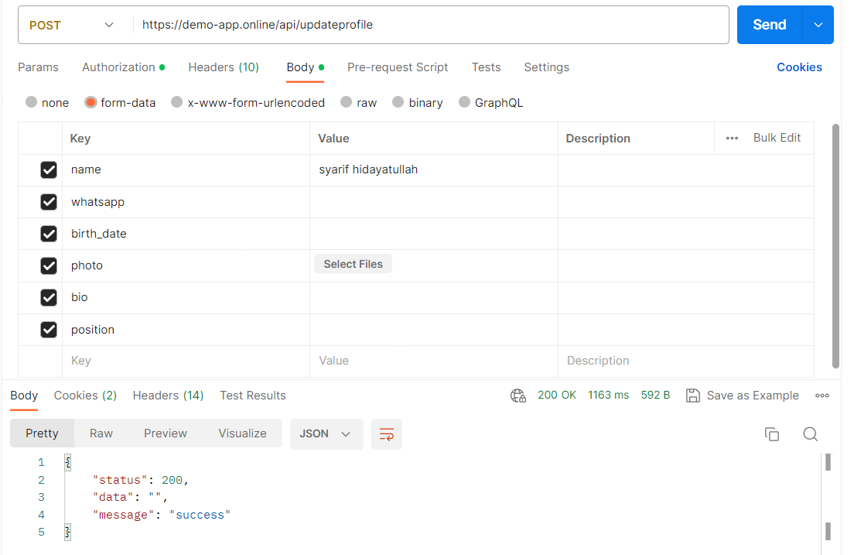

# [TCUP-API-003][Update Profile - WhatsApp] API

status : Passed

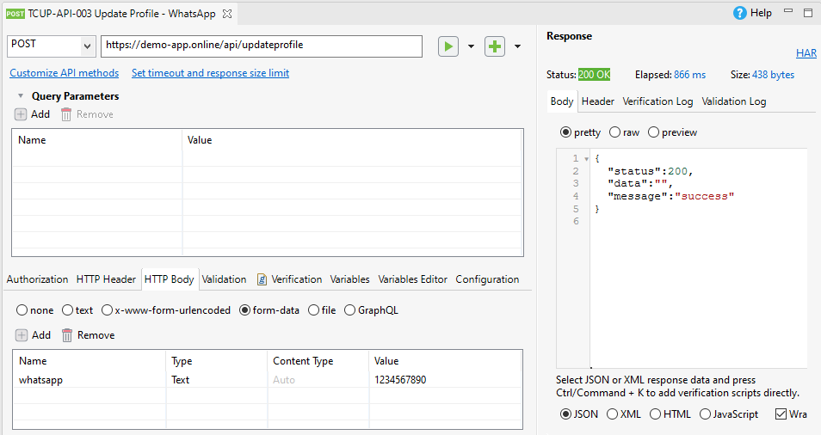

# [TCUP-API-004][Update Profile - Birth_date] API

status : Passed

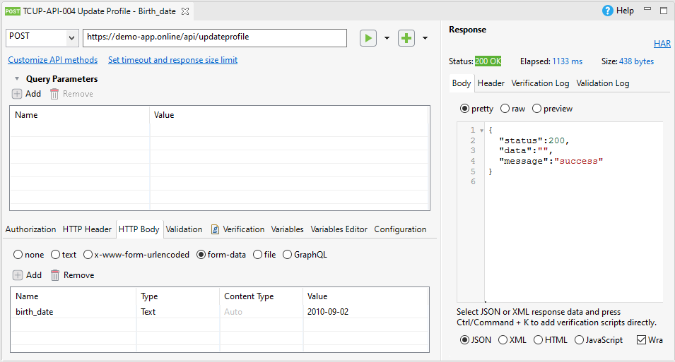

# [TCUP-API-005][Update Profile - Bio] API Login

status : Passed

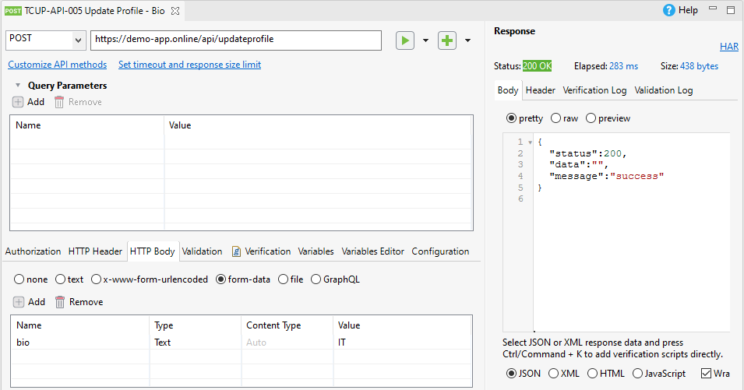

# [TCUP-API-006][Update Profile - Position] API Login

status : Passed

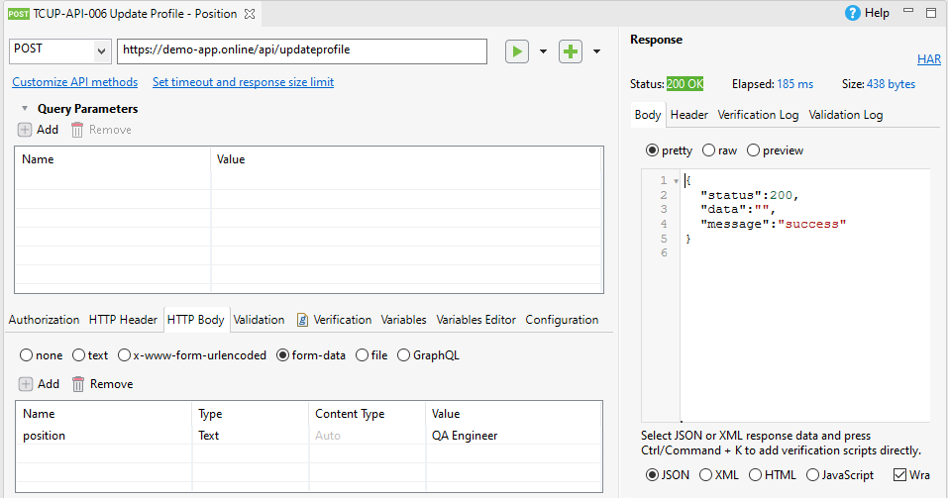

# [TCUP-API-007][Update profile without use token] API Login

status : Passed

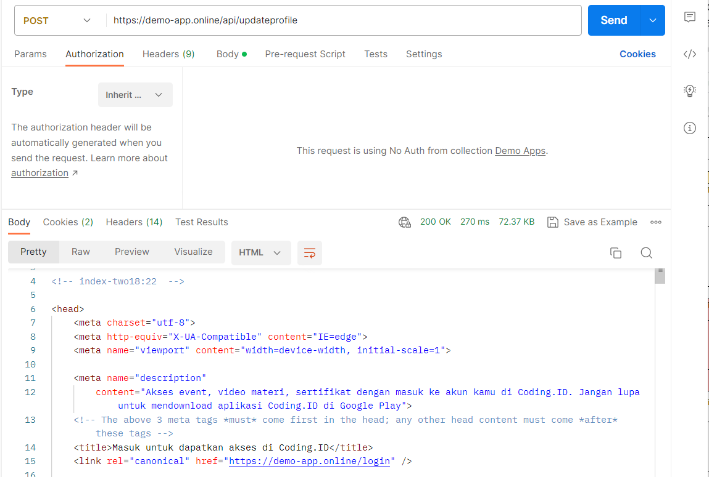

# [TCUP-API-008][Update Profile - Invalid Date] API Login

status : Failed

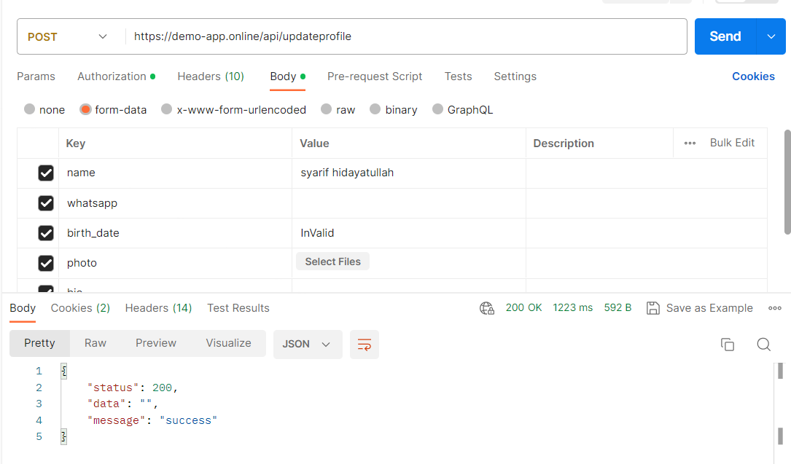

# [TCUP-API-009][Update Profile - Change photo with file not Pictures] API Login

status : Failed

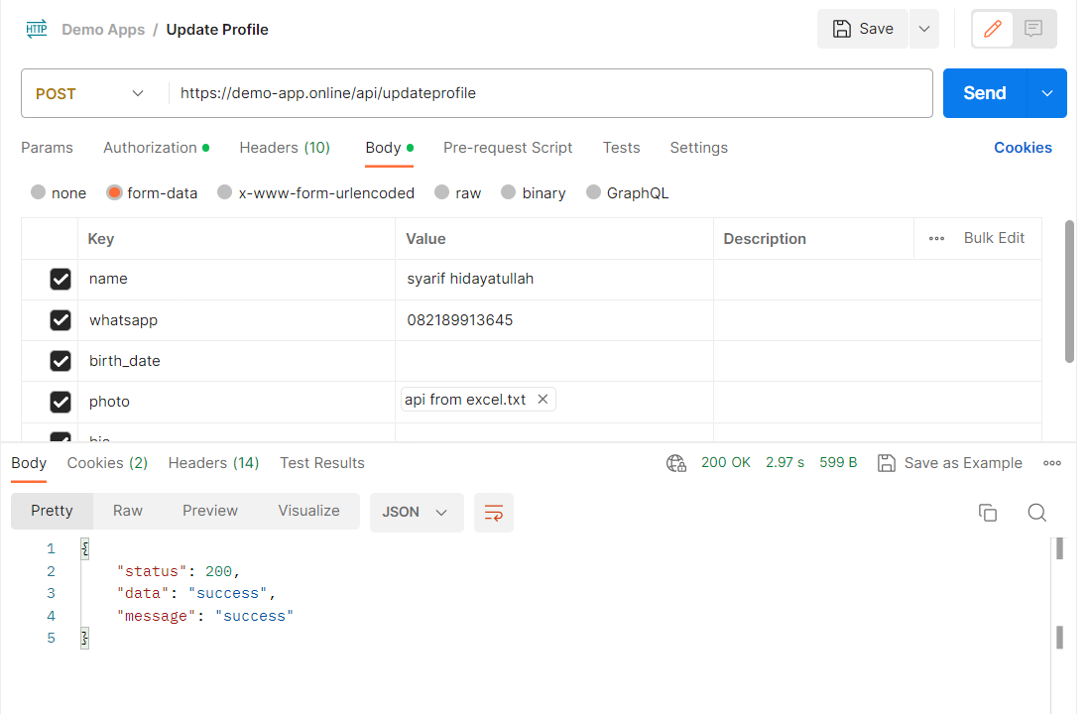

# [TCUP-API-010][Update Profile - Change photo with file not Pictures] API Login

status : Failed

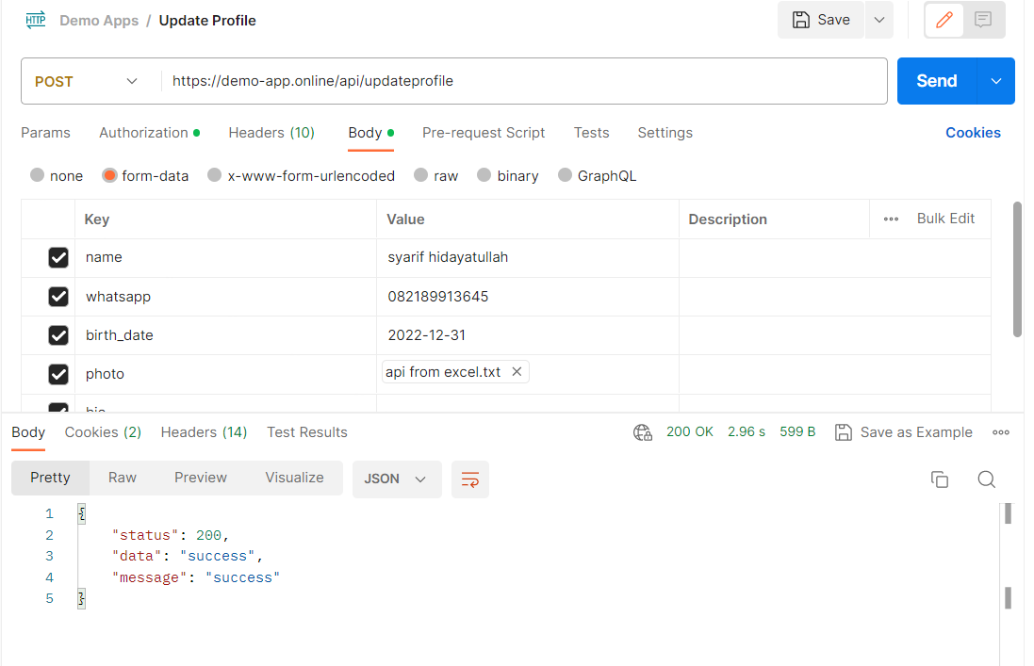

# [TCUP-API-011][Update Profile - Change photo with file not Pictures] API Login

status : Passed